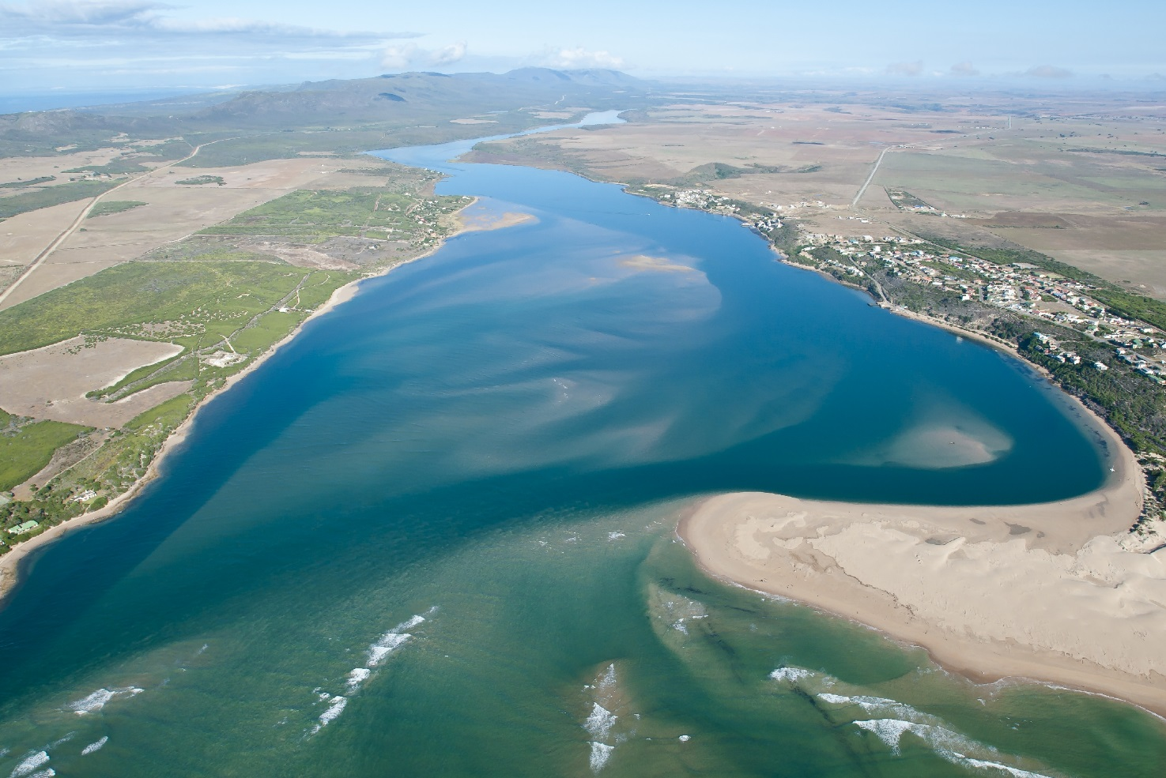




February 2022
TITLE
2018

A DesCription OF SOUTH Africa’s Estuarine ecosystems

Summary of ecosystem description,
status and protection levels



Prepared by:

Dr Lara van Niekerk (CSIR)

With contributions from:

Prof Janine B. Adams (Nelson Mandela University, South Africa)

Dr Stephen J. Lamberth (Department of Environmental, Forestry and Fisheries, South Africa)
Anisha Dayaram (SANBI)

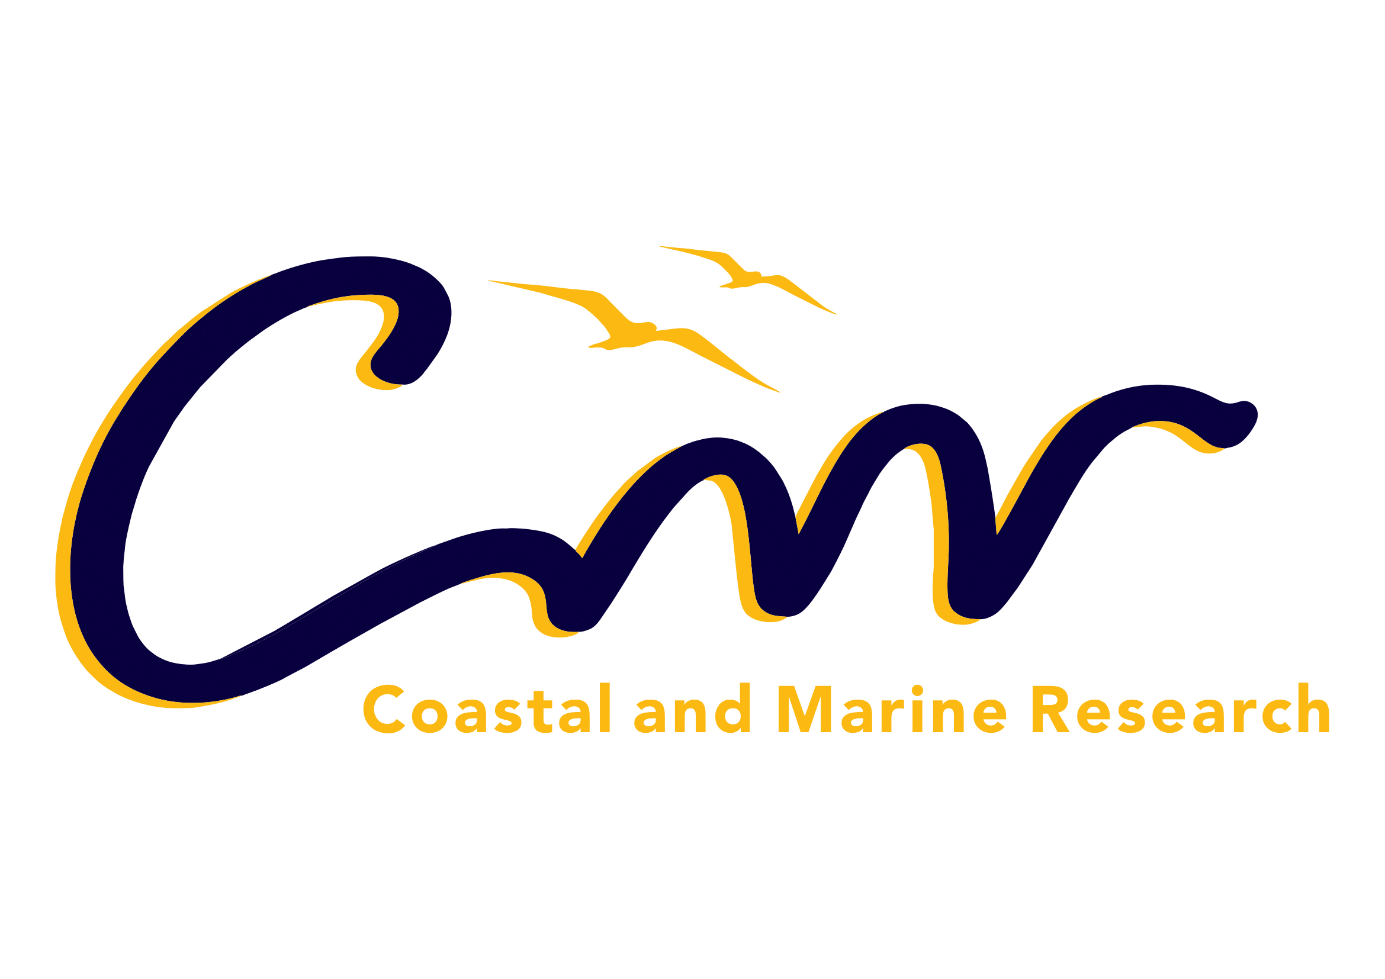
In consultation with:

Andrew Skowno (South African National Biodiversity Institute, South Africa)
Kerry Sink (South African National Biodiversity Institute, South Africa)


This CSIR Research report should be referenced as follows:

Van Niekerk L, Adams, JB, Lamberth, SJ, Dayaram, A 2022. A description of South Africa’s Estuarine Ecosystems. Summary of ecosystem description, threat status and protection levels. Report produced by the Council for Scientific and Industrial Research (CSIR), South Africa. Report No CSIR/SPLA/SECO/….. Final Draft

Council for Scientific and Industrial Research (CSIR)
Smart Places, Coastal Systems Research Group
South Africa

This document is copyright under the Berne Convention. In terms of the Copyright Act, Act No. 98 of 1978, no part of this book/document may be reproduced or transmitted in any form or by any means, electronic or mechanical, including photocopying, recording or by any information storage and retrieval system, without permission in writing from the CSIR.

Front cover: Breede-

Content

Content i
List of Figures iii
List of Tables iv
Abbreviations/Terminology v

1. Introduction 1
1.1 Scope and Purpose 1
1.2 Estuary Ecosystem Types 1
1.3 Estuarine Functional Zone 2

2. Cool Temperate Arid Predominantly Closed 5
3. Cool Temperate Estuarine Lagoon 8
4. Cool Temperate Estuarine Lake 11
5. Cool Temperate Large Fluvially Dominated 14
6. Cool Temperate Large Temporarily Closed 17
7. Cool Temperate Predominantly Open 20
8. Cool Temperate Small Fluvially Dominated 23
9. Cool Temperate Small Temporarily Closed 26
10. Warm Temperate Estuarine Bay 29
11. Warm Temperate Estuarine Lake 32
12. Warm Temperate Large Fluvially Dominated 35
13. Warm Temperate Large Temporarily Closed 38
14. Warm Temperate Predominantly Open 42
15. Warm Temperate Small Fluvially Dominated 45
16. Warm Temperate Small Temporarily Closed 48
17. Subtropical Estuarine Bay 52
18. Subtropical Estuarine Lake 55
19. Subtropical Large Fluvially Dominated 58
20. Subtropical Predominantly Open 61
21. Subtropical Large Temporarily Closed 64
22. Subtropical Small Temporarily Closed 68
23. Tropical Estuarine Lake 72
24. Micro-estuaries (Not Assessed) 75
24.1 Cool Temperate Micro-estuary 75
24.2 Warm Temperate Micro-estuary 77
24.3 Subtropical Micro-estuary 79

25. References 81

List of Figures

Figure 1.1: Location of functional types across four biogeographical regions (1: Cool Temperate; 2= Warm Temperate; 3 & 4 = Subtropical; 5 = Tropical) (Source: Van Niekerk et al. 2019a, 2020a) 2
Figure 1.2: Estuarine Functional Zone delineation of South Africa estuaries – note the relative small size except for the Greater St Lucia Lake system (upper right) 4

List of Tables

Table 1.1: Distribution of estuary functional types across four biogeographical regions (Van Niekerk et al. 2020a) 1

Abbreviations/Terminology

a | annum
C | Cool Temperate biogeographical region
CBD | Convention on Biological Diversity
CSIR | Council for Scientific and Industrial Research
d | day
DEFF | Department of Forestry and Fisheries, and the Environment (since 2019)
EFZ | Estuary Functional Zone
ha | Hectare
m³ | Cubic meters
MAR | Mean Annual Runoff
Mg | Megagram (metric ton)
Mg C ha⁻¹ | Megagram of Carbon per hectare
MPA | Marine Protected Area
NBA | National Biodiversity Assessment
NEMA | National Environmental Management Act (No. 107 of 1998)
NMU | Nelson Mandela University
S | Subtropical biogeographical region
SA | South Africa
SANBI | South African National Biodiversity Institute
t | Tonne (1,000 kilograms)
T | Tropical biogeographical region
W | Warm Temperate biogeographical region
WWTW | Wastewater Treatment Works

Introduction

1.1 Scope and Purpose
The purpose of this document is to summarise available information on the estuarine ecosystem types of South Africa. Information was collated and tabulated in a user-friendly manner, that can serve as the reference content for generating factsheets, web content or press releases.
The document should be treated as a living document and information on ecosystem types, habitats and species added as new information becomes available.

1.2 Estuary Ecosystem Types
South Africa’s 22 Estuarine Ecosystem Types are derived from an intersection of four biogeographical zones with the nine estuary functional types (Van Niekerk et al. 2019a; Van Niekerk et al. 2020a). Table 1.1 illustrates this interplay and lists the number of estuaries that occur within each ecosystem type, biogeographical region and /or estuary functional type. Figure 1.1 shows the distribution of the estuary functional type within the biogeographical regions.
Table 1.1: Distribution of estuary functional types across four biogeographical regions (Van Niekerk et al. 2020a)
EstuarY FUNCTIONAL Type | BIOGEOGRAPHICAL REGIONS |  |  |  |  | # EstuarIES PER FUNCTIONAL TYPE
EstuarY FUNCTIONAL Type | Cool Temperate | Warm Temperate | Subtropical |  | Tropical | # EstuarIES PER FUNCTIONAL TYPE
Estuarine Lake | 4 | 3 | 2¹ | 2 |  | 11
Estuarine Bay |  | 1 | 2¹ |  |  | 3
Estuarine Lagoon | 1 |  |  |  |  | 1
Predominantly Open | 3 | 25 | 17¹ |  |  | 45
Large Temporarily Closed | 9 | 40 | 45 |  |  | 94
Small Temporarily Closed | 8 | 48 | 60 |  |  | 116
Large Fluvially Dominated | 1 | 1 | 5 |  |  | 7
Small Fluvially Dominated | 1 | 6 |  |  |  | 7
Arid Predominantly Closed | 6 |  |  |  |  | 6
# ESTUARIES PER REGION | 33 | 124 | 131¹ | 2 |  | 290
¹uMhlathuze was an Estuarine Lake but was subdivided into an Estuarine Bay (Richards Bay Estuary) and Predominantly Open System (uMhlathuze Sanctuary) in 1970 through port development
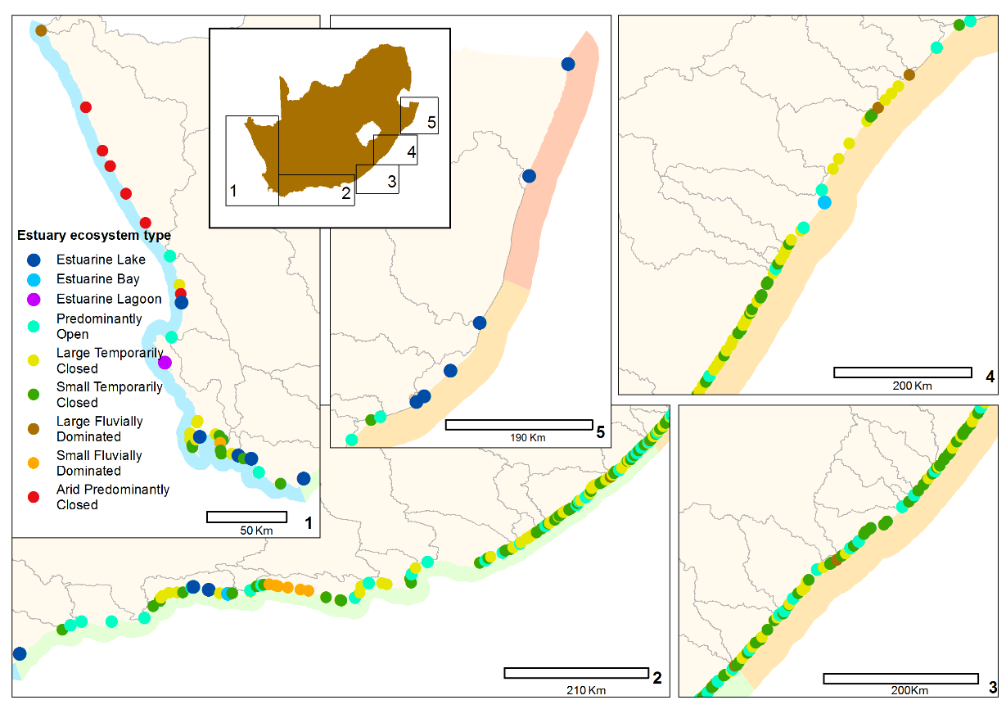

Estuary functional types

Figure 1.1: Location of functional types across four biogeographical regions (1: Cool Temperate; 2= Warm Temperate; 3 & 4 = Subtropical; 5 = Tropical) (Source: Van Niekerk et al. 2019a, 2020a)

1.3 Estuarine Functional Zone
The Estuary Functional Zone (EFZ) is defined as the area that not only covers the estuary water body, but also areas that support physical and biological processes and habitats necessary for estuarine function and condition. The latter includes areas influenced by long-term estuarine sedimentary processes (i.e. sediment stored or eroded during floods), changes in channel configuration, aeolian transport processes, and changes due to coastal storms. The EFZ also encompasses flood plain ecotones and estuarine vegetation that contribute detritus to the base of the estuarine food chain and provide refuge to estuarine biota during high flow events from strong currents.
By nature, estuaries are constantly changing both temporally and spatially, and as a consequence they do not have permanent or static habitat structures. While the total habitat area occupied by various biotic and abiotic habitat types within an estuary tends to remain more or less constant over long time scales, the actual location of these habitats is likely to be highly variable between resetting events (e.g. larger floods on decadal scales).
A fundamental constraint associated with the assessment and management of estuaries is defining their spatial extent (i.e. the smallest management unit or boundary) owing to the dynamic nature of estuarine habitats (van Niekerk and Taljaard 2003). Biodiversity protection and the wise use of our estuarine resources require not only the protection of estuarine habitat and biota, but also the protection of the physical processes that sustain ecological and evolutionary processes. To do this, it is important to define the ‘space’ within which estuaries function over long time scales to safeguard the present and future health – the so-called ‘estuarine functional zone’ (EFZ) (van Niekerk et al. 2013, Van Niekerk et al. 2012, 2019) (Figure 2.1).
The delineation of the EFZ needs to be done in a consistent but cost-effective manner, and be inclusive of all estuarine physical and biological processes so that it can be used to protect estuarine habitats. South Africa’s method for the determination of the EFZ is described in detail in the NBA 2018 (Van Niekerk et al. 2019a). Key aspects that were considered included:
- The EFZs were mapped to their maximum historical extents (based on available data such as the Google Earth time slider tool, aerial photography and satellite imagery). For example, the EFZ included the maximum ranges of the estuary mouth (inlet) or the historical floodplain.
- Upstream boundaries of the EFZ were determined as the limits of tidal variation, back flooding when closed or salinity penetration; whichever penetrates furthest in alignment with recent scientific studies and the administrative definition of an estuary (e.g. DWAF 2008). This boundary was derived from the available literature, expert judgment or field observations. Where no data were available the boundary was assumed to be the DRDLR:NGI 1:10,000 +5m MSL topographical contour (bearing in mind that the tidal range in South Africa is microtidal [< 2 m] and sand bars across mouths can build up as high as +4.5 m MSL during closed periods).
- The default lateral boundary was also taken as the DRDLR: NGI 1:10,000 +5m MSL topographical contour. However, for the small, incised estuaries with relative high river flow, the +10 m MSL contour or a combination of the +5 m and +10 m MSL contours, was used to accommodate mapping uncertainty and flood processes (e.g. inundation levels and lateral scouring of the riparian area). For systems where no topographic information was available the SRTM 4.1 90 Digital Elevation Model was used to generate +5 m and +10 m MSL contour intervals for delineation of the upstream boundaries. Also included in the EFZ was contiguous habitat that is principally (more than 75% of feature) surrounded by estuarine habitat or processes (for example ‘s-bends’ and ‘islands’ of high-lying ground, which could potentially be eroded in future resetting flood events). Small areas of freshwater ecosystems, identified as contiguous to estuaries (e.g. seeps and springs), were also amalgamated in EFZs.
- The alongshore extent was delineated as the known variability in estuary mouth position along the shore-based on the available data sources for each. Freshwater inputs (via an open mouth or seepage through the berm) change the physicochemical nature of coastal waters directly adjacent to estuaries, and are important for estuarine function. Surf zones off estuaries are essentially estuarine extensions during floods and under normal flow conditions are aggregation areas for recruiting estuarine biota. Estuarine fishes and invertebrates use riverine and estuarine signals as cues for locating and recruiting into estuaries (Van Niekerk et al. 2019).

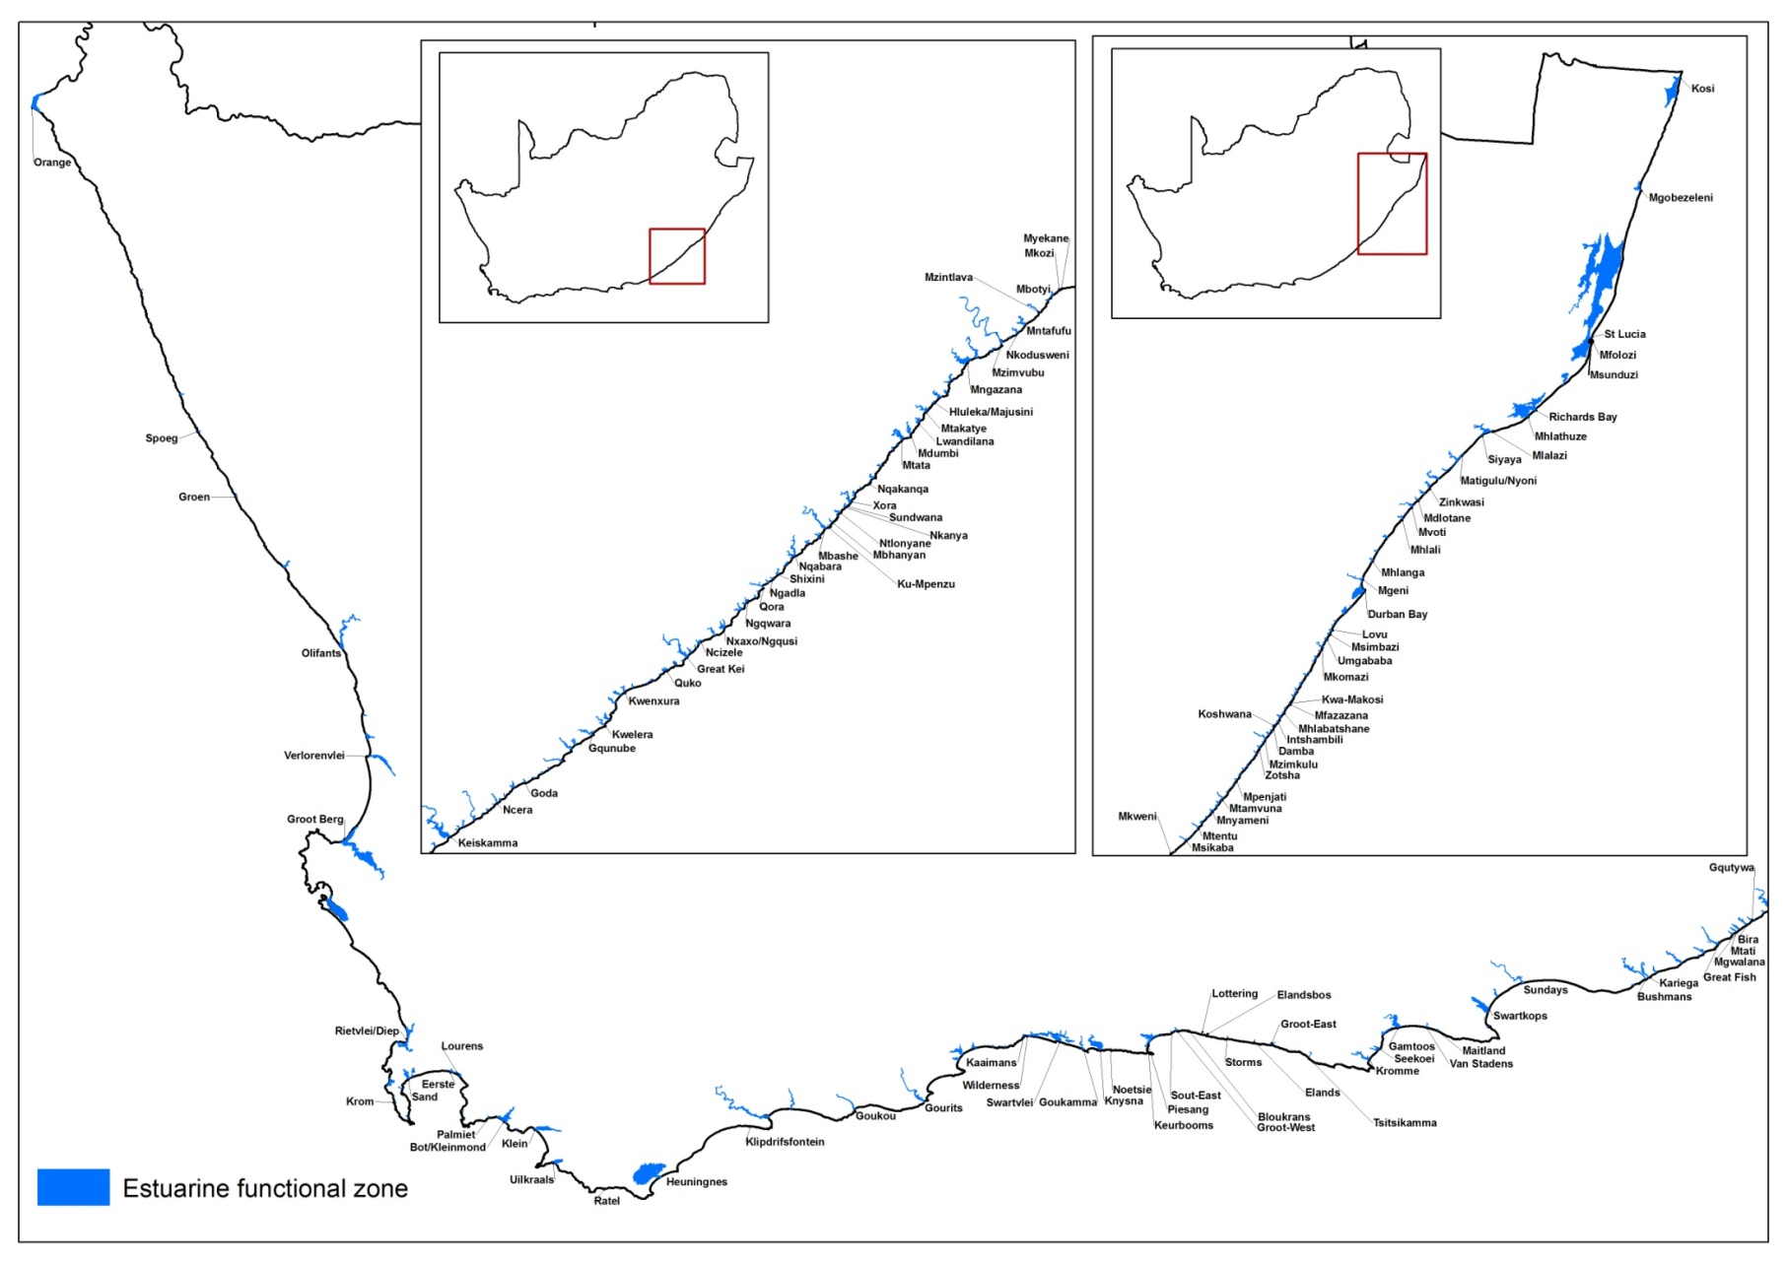

Figure 1.2: Estuarine Functional Zone delineation of South Africa estuaries – note the relative small size except for the Greater St Lucia Lake system (upper right)

Cool Temperate Arid Predominantly Closed

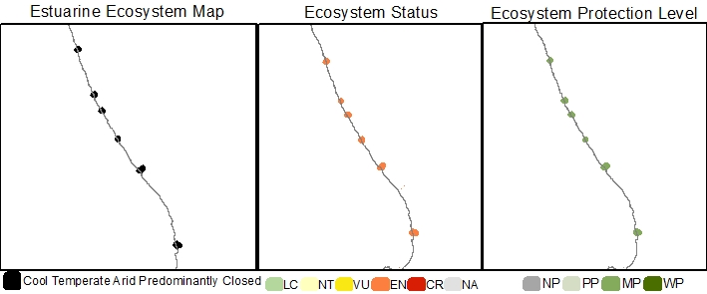
Estuarine Ecosystem type | Cool Temperate Arid Predominantly Closed
Ecosystem type version history | 2018☒
Biogeographical Region | Cool Temperate
Ecosystem Threat Status (IUCN RLE v1.1): | Endangered
Assesment findings | Cool Temperate Arid Predominantly Closed estuaries are threatened by ongoing environmental degradation, specifically from surface and groundwater abstraction, mining, agriculture and pollution pressures.
Trigger criteria: | C3 – Environmental degradation since 1750
Other criteria considered: | A3 – historical and future reductions in geographic range  B3 – Restricted geographic range
Assessment Scope: | National
Assessment type: | Systematic assessment
Date assessed: | 2018/2019
Year published: | 2020
Provincial distribution: | Northern Cape and Western Cape
Historical extent (km²): | 14.4
Remaining natural extent (%): | 22% Near Natural
Conservation Target | 2.9 km² - 20 % (new ecosystem type, not included in 2011 National Estuaries Biodiversity Plan)
Area protected | 13 %
Area under very high & high fishing pressure | 0 %
Protection level from National Biodiversity Assessment 2018: | Moderately protected
Ecosystem description: | This type comprises six small estuaries located along the Namaqua west coast region. They are linear or funnel-shaped and closed on annual to decadal scales (van Niekerk et al., 2020). Salinities tend to be high to hypersaline (>35) as a result of low freshwater input and high evaporation rates. Thus, estuarine mixing processes tend to occur over long time periods and are dominated by the effects of evaporation, winds and seepage. Occasional breaching and over-washing during high sea conditions provide for marine input and connectivity. Sediment processes are generally stable on decadal time scales and are reset by large intermittent flash floods. Water levels are determined by the interplay between sand berm level, evaporation rates and seepage losses. Groundwater and inflows from local fountains replenish these losses and influence the salinity regimes of these estuaries.
Rain season: | Winter
Altitude: | Between 0 masl and 5 masl.
Mean Annual Runoff: | 0.2 to 13.2 x10⁶ m³/annum
Temperature: | Average monthly maximum in summer is between 18-21 °C and average monthly minimum in winter is between 14 and 15°C.
Endemic taxa
Economically important taxa | Cool Temperate Arid Predominantly Closed estuaries support extensive areas of saltmarsh that’s eves as important habitat for birds and reptiles in these arid environments.
Ecologically important taxa | Arid conditions along the west coasts promote the growth of unique vegetation such as salt-tolerant, succulent Sarcocornia spp. and Salicornia spp. that can occur kilometers inland making it difficult to distinguish between arid estuarine salt marsh vegetation and upstream Namaqualand riverine vegetation. These vegetated areas can be stable despite open water salinities reaching above 200 (Wooldridge et al. 2016).  Fish diversity, abundance and community structure rely on ‘suicidal’ recruitment that is largely a function of connectivity with the sea and the degree of overwash during high seas. Fish survival depends mostly on groundwater inflow maintaining a salinity gradient and at least some areas with hypersalinity not exceeding 40. Safe return to the sea is usually during flood events and depends on a quick breach and fish not suffocating in sediment-laden water backing up against the berm. Invertebrate diversity, abundance and community structure are related to changing salinity gradients including long cycles of hypersalinity (Van Niekerk et al 2020).  The Swartlintjies, Sout and Groen are hypersaline with a high biomass of brine Shrimp Artemia sp. that hatch at salinities above 40 and encyst sinking to the bottom when salinities exceed 150. Cycles of Artemia abundance follow salinity regimes that in turn affect the diversity, abundance and occurrence of flamingos and other birds that feed on them (Van Niekerk et al 2020).
Endemic taxa
Primary threatening processes: | 50% of ecosystem extent is under severe (high or very high) flow modification (with especially groundwater reduction a key issue) pressure.  50% of ecosystem extent is under severe land-use change from mostly mining pressure  33% of ecosystem extent under severe pollution pressure.  17% of ecosystem extent is under severe mouth manipulation pressure.  17% of ecosystem extent is under severe alien invasive plant pressure in one or more of their reaches.  No fishing pressure.
Limitations and knowledge gaps | Ground truthing of ecosystem assessment was undertaken in 2016. No field work or systematic monitoring have been conducted since then.  Estuaries are interconnected over local, bioregional and global scales. Ecosystems threat status are just one of a range of measures that document the decline in condition and the response to an escalating human footprint. The results of the ecosystem threat status assessment should not be decoupled from the overall regional findings and the deeply concerning trend of large gaps in functioning estuaries due to collective poor condition along urban coastlines.  Ecosystem protection levels are just one of a range of measures that document the progress in the protection of estuaries. The results of the ecosystems protection level assessment should not be decoupled from progress in environmental flow allocations, fisheries control measures and land-use and infrastructure development processes and measures. Estuaries are open systems and can only be judged to be well protected if all these aspects are concurrently addressed.
Estuaries in Ecosystem (estuary ID) | Buffels (2)  Swartlintjies (3)  Spoeg (4)  Groen (5)  Sout (Noord) (6)  Wadrift (9)
Assessors | Van Niekerk, L., Adams, J.B., Lamberth, S.J., Turpie, J., MacKay, F., Sink, K. & Skowno, A.L
Reviewers | National Biodiversity Assessment Estuaries Reference Group (2016-2019) (2018 version).
Data sources | Dayaram, A., Skowno, A.L., Driver, A., Sink, K., Van Deventer, H., Smith-Adao, L., Van Niekerk, L., Harris, L.R., Job, N. & Nel, J.L. 2021. The South African National Ecosystem Classification System Handbook: First Edition. South African National Biodiversity Institute, Pretoria, South Africa. http://hdl.handle.net/20.500.12143/7150  GeoTerraImage (2015) Technical Report: 1990 South African National Land Cover Dataset version 5.2. Pretoria, 63 pp. SANBI Threatened Species Unit pers com (2020) Threatened plant species database of South Africa.  Van Niekerk, L, Adams JB, James, N, Lamberth S, Mackay F, Rajkaran A, Turpie J, Weerts S, Whitfield AK. 2020. An Estuary Ecosystem Classification that encompasses biogeography and a high diversity of types in support of protection and management. African Journal of Aquatic Science, 45: 199-216.  Van Niekerk, L., Adams, J.B., Lamberth, S.J., Turpie, J., MacKay, F., Sink, K. & Skowno, A.L., 2019, ‘Chapter 8: Ecosystem Threat Status and Protection levels’ in South African National Biodiversity Assessment 2018: Technical Report. Volume 3: Estuarine Realm. CSIR report number CSIR/SPLA/EM/EXP/2019/0062/A. South African National Biodiversity Institute, Pretoria. Report Number: http://hdl.handle.net/20.500.12143/6373.  Wooldridge, T.H., Adams, J.B. & Fernandes, M., 2016. ‘South African Journal of Botany Biotic responses to extreme hypersalinity in an arid zone estuary, South Africa’, South African Journal of Botany, 107, 160–169.
Author (s) of Factsheet | Van Niekerk, L., Adams, J.B., Lamberth, Dayaram, A.
Recommended Citation | Van Niekerk, L., Adams, J.B., Lamberth, Dayaram, A. (2022). Cool Temperate Arid Predominantly Closed in A description of South Africa’s estuarine ecosystems, summary of ecosystem description, status and protection levels, accessed online [add OPUS link]
Image | [Link to images of ecosystem if available].*

Cool Temperate Estuarine Lagoon

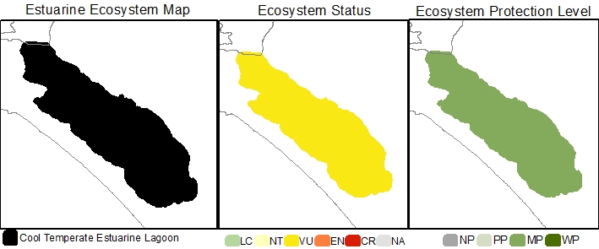
Estuarine Ecosystem type | Cool Temperate Estuarine Lagoon
Ecosystem ID | To be provided by SANBI
NBA 2018 Coastal Classification | Coastal Classification NCM NBA2018 - To be provided by SANBI
Ecosystem type version history | 2018☒ 2024☐
Biogeographical Region | Cool Temperate
Ecosystem Threat Status (IUCN RLE v1.1): | Vulnerable
Assesment findings | The Cool Temperate Estuarine Lagoon Langebaan are one of a kind, unique estuarine type in South Africa. While it is at present in a near-natural state it is under escalating pressure from adjacent port development, pollution, over exploitation and biological invasions.
Trigger criteria: | B3 – Restricted geographic range
Other criteria considered: | C3 – Environmental degradation since 1750  A3 – historical and future reductions in geographic range
Assessment Scope: | National
Assessment type: | Systematic assessment
Date assessed: | 2018/2019
Year published: | 2020
Provincial distribution: | Western Cape
Historical extent (ha): | 60.2
Remaining natural extent (%): | 100% Near natural
Conservation Target | 12 km² - 20 % (new ecosystem type, not included in 2011 National Estuaries Biodiversity Plan)
Area protected | 99%
Area under very high & high fishing pressure | 100 % triggering downgrade to Moderately protected
Protection level from National Biodiversity Assessment 2018: | Moderately protected
Ecosystem description: | Estuarine Lagoons, as defined here, are permanently connected to the sea and are therefore marine dominated. Tidal action is the dominant mixing process and sedimentary processes are thus generally stable. Tidal amplitude and water levels are close to those of the sea (Van Niekerk et al. 2019; 2020).  South Africa has only one Estuarine Lagoon, namely, Langebaan Lagoon. Langebaan has many of the characteristics of an estuary (Whitfield 2005), including calm waters that are protected from marine wave action and biota that reflect many of the species usually found in estuaries. However, despite groundwater seeps into some areas, it lacks riverine inflow and a normal estuarine salinity gradient. Thus, the Lagoon represents a unique coastal ecosystem type and is recognised as an estuary because its ecological functioning includes both freshwater and marine inputs into a semi-enclosed embayment.
Rain season: | Winter
Altitude: | Between 0 masl and 5 masl.
Mean Annual Runoff: | N/A Groundwater fed
Temperature: | Average monthly maximum in summer is 20 °C and Average monthly minimum in winter is 15°C.
Endemic taxa
Economically important taxa
Ecologically important taxa
Endemic taxa
Primary threatening processes: | 100% of ecosystem extent is under severe (high or very high) fishing pressure impacting on higher taxa.  Some land use change, pollution and flow modification pressure.
Limitations and knowledge gaps | While the condition assessments for most systems have been updated, the under-pinning survey data is between 20 and 30 years old. It is therefore of critical importance that more up to date nation-wide surveys be conducted to improve our overall confidence in the estimated change for the different ecosystem types and to inform future assessments.  Estuaries are interconnected over local, bioregional and global scales. Ecosystems threat status are just one of a range of measures that document the decline in condition and the response to an escalating human footprint. The results of the ecosystem threat status assessment should not be decoupled from the overall regional findings and the deeply concerning trend of large gaps in functioning estuaries due to collective poor condition along urban coastlines.  Ecosystems protection levels are just one of a range of measures that document the progress in the protection of estuaries. The results of the ecosystems protection level assessment should not be decoupled from progress in environmental flow allocations, fisheries control measures and land-use and infrastructure development processes and measures. Estuaries are open systems and can only be judged to be well protected if all these aspects are concurrently addressed.
Estuaries in Ecosystem (estuary ID) | Langebaan (12)
Assessors | Van Niekerk, L., Adams, J.B., Lamberth, S.J., Turpie, J., MacKay, F., Sink, K. & Skowno, A.L
Reviewers | National Biodiversity Assessment Estuaries Reference Group (2016-2019) (2018 version).
Data sources | Dayaram, A., Skowno, A.L., Driver, A., Sink, K., Van Deventer, H., Smith-Adao, L., Van Niekerk, L., Harris, L.R., Job, N. & Nel, J.L. 2021. The South African National Ecosystem Classification System Handbook: First Edition. South African National Biodiversity Institute, Pretoria, South Africa. http://hdl.handle.net/20.500.12143/7150  GeoTerraImage (2015) Technical Report: 1990 South African National Land Cover Dataset version 5.2. Pretoria, 63 pp. SANBI Threatened Species Unit pers com (2020) Threatened plant species database of South Africa.  Van Niekerk, L, Adams JB, James, N, Lamberth S, Mackay F, Rajkaran A, Turpie J, Weerts S, Whitfield AK. 2020. An Estuary Ecosystem Classification that encompasses biogeography and a high diversity of types in support of protection and management. African Journal of Aquatic Science, 45: 199-216.  Van Niekerk, L., Adams, J.B., Lamberth, S.J., Turpie, J., MacKay, F., Sink, K. & Skowno, A.L., 2019, ‘Chapter 8: Ecosystem Threat Status and Protection levels’ in South African National Biodiversity Assessment 2018: Technical Report. Volume 3: Estuarine Realm. CSIR report number CSIR/SPLA/EM/EXP/2019/0062/A. South African National Biodiversity Institute, Pretoria. Report Number: http://hdl.handle.net/20.500.12143/6373.
Author (s) of Factsheet | Van Niekerk, L., Adams, J.B., Lamberth, Dayaram, A.
Recommended Citation | South African National Biodiversity Institute (2022-). [Name], Online, webpage link (unknown), accessed on [download date]
Image | [Link to images of ecosystem if available].*

Cool Temperate Estuarine Lake

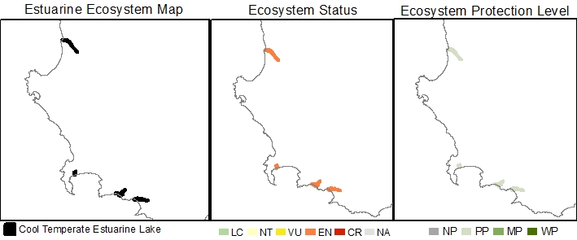
Estuarine Ecosystem type | Cool Temperate Estuarine Lake
Ecosystem ID | To be provided by SANBI
NBA 2018 Coastal Classification | Coastal Classification NCM NBA2018 - To be provided by SANBI
Ecosystem type version history | 2018☒ 2024☐
Biogeographical Region | Cool Temperate
Ecosystem Threat Status (IUCN RLE v1.1): | Endangered
Assesment findings | Cool Temperate Estuarine Lakes are threatened by ongoing environmental degradation, specifically from surface and groundwater abstraction, land-use change, pollution, artificial breaching and overexploitation of living resources pressures.
Trigger criteria: | C3 – Environmental degradation since 1750
Other criteria considered: | A3 – historical and future reductions in geographic range  B3 – Restricted geographic range
Assessment Scope: | National
Assessment type: | Systematic assessment
Date assessed: | 2018/2019
Year published: | 2020
Provincial distribution: | Western Cape
Historical extent (km²): | 72.4
Remaining natural extent (%): | 0%
Conservation Target | 14.5 km² - 20 %
Area protected | 15%
Area under very high & high fishing pressure | 0 %
Protection level from National Biodiversity Assessment 2018: | Poorly protected
Ecosystem description: | Estuarine Lake ecosystems comprise one or more large circular water bodies connected to the sea by a constricted inlet channel (Whitfield 1992; Van Niekerk et al., 2020). Maximum water levels are determined by berm height, mouth state (open/close) and freshwater input. Marine connectivity varies from almost permanently open to closed on annual scales. Salinities are highly variable, ranging from fresh to hypersaline because of differing freshwater input (surface and groundwater), evaporation and the extent of the marine connection (. Mixing processes are dominated by wind and, to a lesser extent fluvial inputs, owing to their restricted mouths and relatively large surface areas. Average tidal amplitudes are negligible (15 – 20 cm) when connected to the sea, primarily due to restricted mouth conditions. Sediment processes tend to be stable, with infilling occurring over long time scales and resetting confined to larger flood events.
Rain season: | Winter
Altitude: | Between 0 masl and 5 masl.
Mean Annual Runoff: | 22.3 to 89.0 x10⁶ m³/annum
Temperature: | Average monthly maximum in summer is between 19 and 20 °C and Average monthly minimum in winter is between 12 and 12°C.
Endemic taxa
Economically important taxa
Ecologically important taxa
Endemic taxa
Primary threatening processes: | 100% of ecosystem extent under severe pollution pressure (very high to high levels) from Wastewater Treatment works, urban storm water and agricultural return flow.  100% of ecosystem extent is under severe alien/extralimital fish pressure causing disruption of pattern and process in brackish and fresh zones of the systems.  50% of ecosystem extent is under severe flow modification pressure.  50% of ecosystem extent is under severe land-use change (mostly urban development and agriculture) pressure  50% of ecosystem extent is under severe fishing pressure.  50% of ecosystem extent is under severe mouth manipulation pressure.  50% of ecosystem extent is under severe alien invasive plant pressure in one or more of their reaches.
Limitations and knowledge gaps | While the condition assessments for most systems have been updated, the under-pinning survey data is between 20 and 30 years old. It is therefore of critical importance that more up to date nation-wide surveys be conducted to improve our overall confidence in the estimated change for the different ecosystem types and to inform future assessments.  Estuaries are interconnected over local, bioregional and global scales. Ecosystems threat status are just one of a range of measures that document the decline in condition and the response to an escalating human footprint. The results of the ecosystem threat status assessment should not be decoupled from the overall regional findings and the deeply concerning trend of large gaps in functioning estuaries due to collective poor condition along urban coastlines.
Estuaries in Ecosystem (estuary ID) | Verlorenvlei (10)  Zeekoei (21)  Bot/Kleinmond (29)  Klein (31)
Assessors | Van Niekerk, L., Adams, J.B., Lamberth, S.J., Turpie, J., MacKay, F., Sink, K. & Skowno, A.L
Reviewers | National Biodiversity Assessment Estuaries Reference Group (2016-2019) (2018 version).
Data sources | Dayaram, A., Skowno, A.L., Driver, A., Sink, K., Van Deventer, H., Smith-Adao, L., Van Niekerk, L., Harris, L.R., Job, N. & Nel, J.L. 2021. The South African National Ecosystem Classification System Handbook: First Edition. South African National Biodiversity Institute, Pretoria, South Africa. http://hdl.handle.net/20.500.12143/7150  GeoTerraImage 2015. Technical Report: 1990 South African National Land Cover Dataset version 5.2. Pretoria, 63 pp. SANBI Threatened Species Unit pers com (2020) Threatened plant species database of South Africa.  Van Niekerk, L, Adams JB, James, N, Lamberth S, Mackay F, Rajkaran A, Turpie J, Weerts S, Whitfield AK. 2020. An Estuary Ecosystem Classification that encompasses biogeography and a high diversity of types in support of protection and management. African Journal of Aquatic Science, 45: 199-216.  Van Niekerk, L., Adams, J.B., Lamberth, S.J., Turpie, J., MacKay, F., Sink, K. & Skowno, A.L., 2019, ‘Chapter 8: Ecosystem Threat Status and Protection levels’ in South African National Biodiversity Assessment 2018: Technical Report. Volume 3: Estuarine Realm. CSIR report number CSIR/SPLA/EM/EXP/2019/0062/A. South African National Biodiversity Institute, Pretoria. Report Number: http://hdl.handle.net/20.500.12143/6373.  Whitfield, A.K., 1992, ‘ A characterisation of southern African estuarine systems’, Southern African Journal of Aquatic Sciences, 12: 89-103. Whitfield, A.K.,1994, ‘An estuary-association classification for the fishes of southern Africa’, South African Journal of Science, 90: 411-417.
Author (s) of Factsheet | Van Niekerk, L., Adams, J.B., Lamberth, Dayaram, A.
Recommended Citation | South African National Biodiversity Institute (2022-). [Name], Online, webpage link (unknown), accessed on [download date]
Image | [Link to images of ecosystem if available].*

Cool Temperate Large Fluvially Dominated

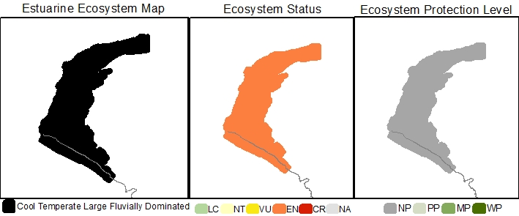
Estuarine Ecosystem type | Cool Temperate Large Fluvially Dominated
Ecosystem ID | To be provided by SANBI
NBA 2018 Coastal Classification | Coastal Classification NCM NBA2018 - To be provided by SANBI
Ecosystem type version history | 2018☒ 2024☐
Biogeographical Region | Cool Temperate
Ecosystem Threat Status (IUCN RLE v1.1): | Endangered
Assesment findings | Cool Temperate Large Fluvially Dominated estuaries are threatened by ongoing environmental degradation, specifically from flow reduction, pollution and land-use change pressures.
Trigger criteria: | C3 – Environmental degradation since 1750
Other criteria considered: | A3 – historical and future reductions in geographic range  B3 – Restricted geographic range
Assessment Scope: | National
Assessment type: | Systematic assessment
Date assessed: | 2018/2019
Year published: | 2020
Provincial distribution: | Northern Cape
Historical extent (km²): | 30.2
Remaining natural extent (%): | 0
Conservation Target | 6 km² - 20 % (new ecosystem type, not included in 2011 National Estuaries Biodiversity Plan)
Area protected | 0%
Natural area under very high & high fishing pressure | 0 %
Protection level from National Biodiversity Assessment 2018: | Not protected
Ecosystem description: | Large Fluvially Dominated estuaries are large, shallow, sediment-rich, freshwater dominated systems with a very high sediment turnover, often develop ebb-tidal deltas, are turbid and can close during periods of low flow, e.g. uThukela and Orange estuaries. Estuary mouths tend to be constricted and can even periodically close during low flows. River processes are dominant, and salinities are mostly fresh throughout the estuary for more than half the time. During peak flood conditions, outflows can influence salinities for considerable distances offshore. Fluvially Dominated systems was previous characterised as river mouths by Whitfield (1992).
Rain season: | Late Summer
Altitude: | Between 0 masl and 5 masl.
Mean Annual Runoff: | 10 833 x10⁶ m³/annum
Temperature: | Average monthly maximum in summer is 20 °C and Average monthly minimum in winter is 15°C.
Endemic taxa
Economically important taxa
Ecologically important taxa
Endemic taxa
Primary threatening processes: | 100% of ecosystem extent is under severe (high or very high) flow modification, pollution and land-use change and infrastructure development pressure.  There are some fishing pressure.
Limitations and knowledge gaps | While the condition assessments for this ecosystem system have been updated, the under-pinning survey data is more than a decade old. As this ecosystem type (represented by the Orange Estuary) are under severe pressure (flow reduction, mining and pollution) and in continuous decline, it is of critical importance that more up to date surveys and continuous monitoring be conducted to improve the overall confidence in the assessment. This includes updated hydrology to the system, to show the impact of dam development over longer timescales.  Estuaries are interconnected over local, bioregional and global scales. Ecosystems threat status are just one of a range of measures that document the decline in condition and the response to an escalating human footprint. The results of the ecosystem threat status assessment should not be decoupled from the overall regional findings and the deeply concerning trend of large gaps in functioning estuaries due to collective poor condition along urban coastlines.
Estuaries in Ecosystem (estuary ID) | Orange (1)
Assessors | Van Niekerk, L., Adams, J.B., Lamberth, S.J., Turpie, J., MacKay, F., Sink, K. & Skowno, A.L
Reviewers | National Biodiversity Assessment Estuaries Reference Group (2016-2019) (2018 version).
Data sources | Dayaram, A., Skowno, A.L., Driver, A., Sink, K., Van Deventer, H., Smith-Adao, L., Van Niekerk, L., Harris, L.R., Job, N. & Nel, J.L. 2021. The South African National Ecosystem Classification System Handbook: First Edition. South African National Biodiversity Institute, Pretoria, South Africa. http://hdl.handle.net/20.500.12143/7150  GeoTerraImage (2015) Technical Report: 1990 South African National Land Cover Dataset version 5.2. Pretoria, 63 pp. SANBI Threatened Species Unit pers com (2020) Threatened plant species database of South Africa.  Van Niekerk, L, Adams JB, James, N, Lamberth S, Mackay F, Rajkaran A, Turpie J, Weerts S, Whitfield AK. 2020. An Estuary Ecosystem Classification that encompasses biogeography and a high diversity of types in support of protection and management. African Journal of Aquatic Science, 45: 199-216.  Van Niekerk, L., Adams, J.B., Lamberth, S.J., Turpie, J., MacKay, F., Sink, K. & Skowno, A.L., 2019, ‘Chapter 8: Ecosystem Threat Status and Protection levels’ in South African National Biodiversity Assessment 2018: Technical Report. Volume 3: Estuarine Realm. CSIR report number CSIR/SPLA/EM/EXP/2019/0062/A. South African National Biodiversity Institute, Pretoria. Report Number: http://hdl.handle.net/20.500.12143/6373.
Author (s) of Factsheet | Van Niekerk, L., Adams, J.B., Lamberth, Dayaram, A.
Recommended Citation | South African National Biodiversity Institute (2022-). [Name], Online, webpage link (unknown), accessed on [download date]
Image | [Link to images of ecosystem if available].*

Cool Temperate Large Temporarily Closed

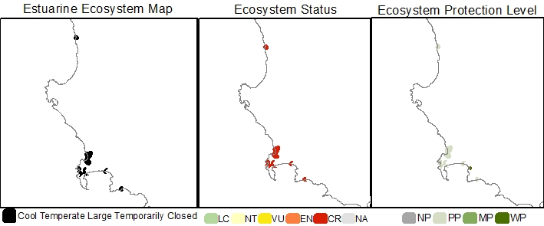
Estuarine Ecosystem type | Cool Temperate Large Temporarily Closed
Ecosystem ID | To be provided by SANBI
NBA 2018 Coastal Classification | Coastal Classification NCM NBA2018 - To be provided by SANBI
Ecosystem type version history | 2018☒ 2024☒
Biogeographical Region | Cool Temperate
Ecosystem Threat Status (IUCN RLE v1.1): | Critically Endangered
Assesment findings | Cool Temperate Large Temporarily Closed estuaries are threatened by ongoing environmental degradation, specifically from land-use change (urban development and agriculture), pollution, water abstraction, mouth manipulations, and biological invasions pressures.
Trigger criteria: | C3 – Environmental degradation since 1750
Other criteria considered: | A3 – historical and future reductions in geographic range  B3 – Restricted geographic range
Assessment Scope: | National
Assessment type: | Systematic assessment
Date assessed: | 2018/2019
Year published: | 2020
Provincial distribution: | Northern Cape and Western Cape
Historical extent (km²): | 39.5
Remaining natural extent (%): | 0%
Conservation Target | 7.9 km² - 20 % (new ecosystem type, not included in 2011 National Estuaries Biodiversity Plan)
Area protected | 44 %
Natural area under very high & high fishing pressure | 0 %
Protection level from National Biodiversity Assessment 2018: | Poorly protected
Ecosystem description: | The extensive temporarily open/closed category of Whitfield (1992) was divided into Large and Small Temporarily Closed estuaries in 2019 using a total habitat area of 15ha (associated with ~10ha of open water area) as the dividing threshold. The division was based on differences in biophysical processes and patterns. Large temporarily closed systems are likely to experience increases and decreases freshwater runoff over hours to days making them highly responsive to changes in runoff. Systems tend to be linear or funnel-shaped with highly restricted inlets. Systems along exposed coastlines especially tend to be ‘perched’ above normal tidal levels, resulting in limited open water area during the open mouth low tide state. Water levels are dominated by the state of the mouth, with highest levels of 1 m to 2 m above mean sea level during the closed phase. Tidal ranges are very restricted, ranging between 25-50 cm. During the open phase mixing processes are dominated by fluvial input and partially by tides. When closed, wind and seepage losses through the berm play a key role. Sediment composition is largely stable, resetting mainly during floods and partially during breaching of the mouth. Salinity regimes range from almost fresh to hypersaline, which can develop during times of low flow or droughts.
Rain season: | Winter
Altitude: | Between 0 masl and 5 masl.
Mean Annual Runoff: | 2.1 to 256.3 x10⁶ m³/annum
Temperature: | Average monthly maximum in summer is between 18-21 °C and Average monthly minimum in winter is between 11 and 13°C.
Endemic taxa
Economically important taxa
Ecologically important taxa
Endemic taxa
Primary threatening processes: | 100% of ecosystem extent is under severe land-use change (mostly urban development and agriculture) pressure  89% of ecosystem extent under severe pollution pressure (very high to high levels) from Wastewater Treatment works, urban storm water and agricultural return flow.  55% of ecosystem extent is under severe flow modification pressure.  67% of ecosystem extent is under severe alien/extralimital fish pressure causing disruption of pattern and process in fresher and brackish zones.  22% of ecosystem extent is under severe mouth manipulation pressure.  22% of ecosystem extent is under severe alien invasive plant pressure in one or more of their reaches.  Some fishing pressure.
Limitations and knowledge gaps | While the condition assessments for most systems have been updated, the under-pinning survey data is between 20 and 30 years old. It is therefore of critical importance that more up to date nation-wide surveys be conducted to improve our overall confidence in the estimated change for the different ecosystem types and to inform future assessments.  Estuaries are interconnected over local, bioregional and global scales. Ecosystems threat status are just one of a range of measures that document the decline in condition and the response to an escalating human footprint. The results of the ecosystem threat status assessment should not be decoupled from the overall regional findings and the deeply concerning trend of large gaps in functioning estuaries due to collective poor condition along urban coastlines.
Estuaries in Ecosystem (estuary ID) | Jakkals (8)  Diep/Rietvlei (13)  Sout (Wes) (14)  Disa (15)  Wildevoelvlei (16)  Silwermyn (19)  Zand (20)  Eerste (22)  Palmiet (28)
Assessors | Van Niekerk, L., Adams, J.B., Lamberth, S.J., Turpie, J., MacKay, F., Sink, K. & Skowno, A.L
Reviewers | National Biodiversity Assessment Estuaries Reference Group (2016-2019) (2018 version).
Data sources | Dayaram, A., Skowno, A.L., Driver, A., Sink, K., Van Deventer, H., Smith-Adao, L., Van Niekerk, L., Harris, L.R., Job, N. & Nel, J.L. 2021. The South African National Ecosystem Classification System Handbook: First Edition. South African National Biodiversity Institute, Pretoria, South Africa. http://hdl.handle.net/20.500.12143/7150  GeoTerraImage (2015) Technical Report: 1990 South African National Land Cover Dataset version 5.2. Pretoria, 63 pp. SANBI Threatened Species Unit pers com (2020) Threatened plant species database of South Africa.  Van Niekerk, L, Adams JB, James, N, Lamberth S, Mackay F, Rajkaran A, Turpie J, Weerts S, Whitfield AK. 2020. An Estuary Ecosystem Classification that encompasses biogeography and a high diversity of types in support of protection and management. African Journal of Aquatic Science, 45: 199-216.  Van Niekerk, L., Adams, J.B., Lamberth, S.J., Turpie, J., MacKay, F., Sink, K. & Skowno, A.L., 2019, ‘Chapter 8: Ecosystem Threat Status and Protection levels’ in South African National Biodiversity Assessment 2018: Technical Report. Volume 3: Estuarine Realm. CSIR report number CSIR/SPLA/EM/EXP/2019/0062/A. South African National Biodiversity Institute, Pretoria. Report Number: http://hdl.handle.net/20.500.12143/6373.
Author (s) of Factsheet | Van Niekerk, L., Adams, J.B., Lamberth, Dayaram, A.
Recommended Citation | South African National Biodiversity Institute (2022-). [Name], Online, webpage link (unknown), accessed on [download date]
Image | [Link to images of ecosystem if available].*

Cool Temperate Predominantly Open

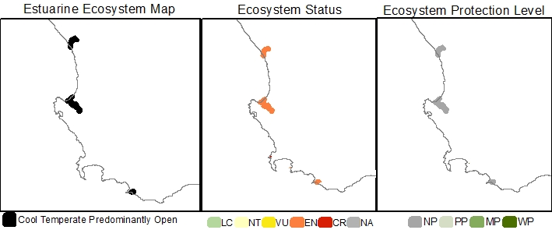
Estuarine Ecosystem type | Cool Temperate Predominantly Open
Ecosystem ID | To be provided by SANBI
NBA 2018 Coastal Classification | Coastal Classification NCM NBA2018 - To be provided by SANBI
Ecosystem type version history | 2018☒ 2024☐
Biogeographical Region | Cool Temperate
Ecosystem Threat Status (IUCN RLE v1.1): | Endangered
Assesment findings | The Cool Temperate Predominantly Open estuaries are experiencing historical reductions in geographic range, both in extent and as estuary ‘type change’ to temporarily closed systems. These systems are also threatened by ongoing environmental degradation, specifically from pollution, land-use change, water abstraction, and biological invasions pressures.
Trigger criteria: | A3 – historical and future reductions in geographic range
Other criteria considered: | C3 – Environmental degradation since 1750  B3 – Restricted geographic range
Assessment Scope: | National
Assessment type: | Systematic assessment
Date assessed: | 2018/2019
Year published: | 2020
Provincial distribution: | Western Cape
Historical extent (km²): | 154.6
Remaining natural extent (%): | 0%
Conservation Target | 30.9 km² (20 %)
Area protected | 1%
Area under very high & high fishing pressure | 0 %
Protection level from National Biodiversity Assessment 2018: | Not protected
Ecosystem description: | Estuaries in this ecosystem type are open to the sea for more than 90% of the time (Whitfield 1992; Van Niekerk et al. 2019; 2020). Some are permanently open owing to perennial river flows or the presence of large tidal prisms. Tidal amplitude ranges from 0.75-1.5 m. Predominantly Open estuaries are linear systems in which mixing processes are dominated by both fluvial inputs and tidal action creating vertical and horizontal salinity gradients. Under low flows, hypersalinity can develop in the upper reaches of the temperate systems.  The degree to which the mouth is restricted depends on the rate and volume of freshwater inflow. Some systems become severely constricted during low flow periods, decreasing the tidal amplitude and increasing the duration of the ebb-tidal cycle. Regular flooding results in relatively mobile sediments. Surprisingly, their size varies considerably, with smaller systems afforded a degree of protection against direct wave action by rocky headlands or subtidal reefs, which assists in maintaining an open mouth.
Rain season: | Winter
Altitude: | Between 0 masl and 5 masl.
Mean Annual Runoff: | 39.3 to 1 070.1 x10⁶ m³/annum
Temperature: | Average monthly maximum in summer is between 19-22 °C and Average monthly minimum in winter is between 13 and 15°C.
Endemic taxa
Economically important taxa
Ecologically important taxa
Endemic taxa
Primary threatening processes: | 100% of ecosystem extent under severe pollution pressure (very high to high levels) from Wastewater Treatment works, urban storm water and agricultural return flow.  100% of ecosystem extent is under severe land-use change (mostly urban development and agriculture) pressure  67% of ecosystem extent is under severe alien/extralimital fish pressure causing disruption of pattern and process in fresher and brackish zones.  66% of ecosystem extent is under severe fishing pressure.  33% of ecosystem extent is under severe flow modification pressure.  33% of ecosystem extent is under severe alien invasive plant pressure in one or more of their reaches.
Limitations and knowledge gaps | While the condition assessments for most systems have been updated, the under-pinning survey data is between 20 and 30 years old. It is therefore of critical importance that more up to date nation-wide surveys be conducted to improve our overall confidence in the estimated change for the different ecosystem types and to inform future assessments.  Estuaries are interconnected over local, bioregional and global scales. Ecosystems threat status are just one of a range of measures that document the decline in condition and the response to an escalating human footprint. The results of the ecosystem threat status assessment should not be decoupled from the overall regional findings and the deeply concerning trend of large gaps in functioning estuaries due to collective poor condition along urban coastlines.
Estuaries in Ecosystem (estuary ID) | Olifants (7)  Groot Berg (11)  Uilkraals (32)
Assessors | Van Niekerk, L., Adams, J.B., Lamberth, S.J., Turpie, J., MacKay, F., Sink, K. & Skowno, A.L
Reviewers | National Biodiversity Assessment Estuaries Reference Group (2016-2019) (2018 version).
Data sources | Dayaram, A., Skowno, A.L., Driver, A., Sink, K., Van Deventer, H., Smith-Adao, L., Van Niekerk, L., Harris, L.R., Job, N. & Nel, J.L. 2021. The South African National Ecosystem Classification System Handbook: First Edition. South African National Biodiversity Institute, Pretoria, South Africa. http://hdl.handle.net/20.500.12143/7150  GeoTerraImage (2015) Technical Report: 1990 South African National Land Cover Dataset version 5.2. Pretoria, 63 pp. SANBI Threatened Species Unit pers com (2020) Threatened plant species database of South Africa.  Van Niekerk, L, Adams JB, James, N, Lamberth S, Mackay F, Rajkaran A, Turpie J, Weerts S, Whitfield AK. 2020. An Estuary Ecosystem Classification that encompasses biogeography and a high diversity of types in support of protection and management. African Journal of Aquatic Science, 45: 199-216.  Van Niekerk, L., Adams, J.B., Lamberth, S.J., Turpie, J., MacKay, F., Sink, K. & Skowno, A.L., 2019, ‘Chapter 8: Ecosystem Threat Status and Protection levels’ in South African National Biodiversity Assessment 2018: Technical Report. Volume 3: Estuarine Realm. CSIR report number CSIR/SPLA/EM/EXP/2019/0062/A. South African National Biodiversity Institute, Pretoria. Report Number: http://hdl.handle.net/20.500.12143/6373.
Author (s) of Factsheet | Van Niekerk, L., Adams, J.B., Lamberth, Dayaram, A.
Recommended Citation | South African National Biodiversity Institute (2022-). [Name], Online, webpage link (unknown), accessed on [download date]
Image | [Link to images of ecosystem if available].*

Cool Temperate Small Fluvially Dominated

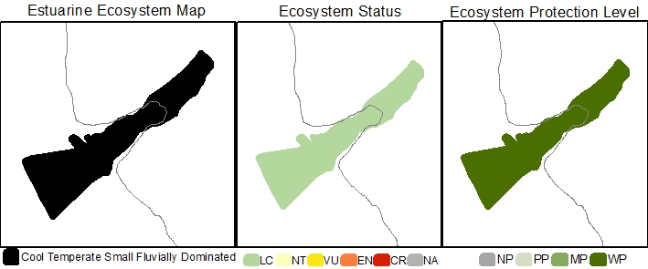
Estuarine Ecosystem type | Cool Temperate Small Fluvially Dominated
Ecosystem ID | To be provided by SANBI
NBA 2018 Coastal Classification | Coastal Classification NCM NBA2018 - To be provided by SANBI
Ecosystem type version history | 2018☒ 2024☐
Biogeographical Region | Cool Temperate
Ecosystem Threat Status (IUCN RLE v1.1): | Least Concern
Assesment findings | Currently there are no substantial, known biotic disruptions or pressures, as such it is considered Least Concern.
Trigger criteria: | -
Other criteria considered: | C3 – Environmental degradation since 1750  A3 – historical and future reductions in geographic range  B3 – Restricted geographic range
Assessment Scope: | National
Assessment type: | Systematic assessment
Date assessed: | 2018/2019
Year published: | 2020
Provincial distribution: | Western Cape
Historical extent (km²): | <0.1
Remaining natural extent (%): | 100% Near natural
Conservation Target | <0.1 km² - 20 % (new ecosystem type, not included in 2011 National Estuaries Biodiversity Plan)
Area protected | 38%
Area under very high & high fishing pressure | 0 %
Protection level from National Biodiversity Assessment 2018: | Well protected
Ecosystem description: | Small Fluvially Dominated systems are small (<15 ha), sediment-starved, fluvially-dominated systems that have unrestricted mouths as they usually occur along rocky shores and receive clear humic-stained water from Table Mountain Sandstone catchments (Van Niekerk et al., 2019; 2020). Fluvially Dominated systems was previous characterised as river mouths by Whitfield (1992).
Rain season: | Winter
Altitude: | Between 0 masl and 5 masl.
Mean Annual Runoff: | 33.7 x10⁶ m³/annum
Temperature: | Average monthly maximum in summer is 12 °C and Average monthly minimum in winter is 20°C.
Endemic taxa
Economically important taxa
Ecologically important taxa
Endemic taxa
Primary threatening processes: | 100% of ecosystem extent under severe flow modification pressure (very high to high levels).
Limitations and knowledge gaps | While the condition assessments for most systems have been updated, the under-pinning survey data is between 20 and 30 years old. It is therefore of critical importance that more up to date nation-wide surveys be conducted to improve our overall confidence in the estimated change for the different ecosystem types and to inform future assessments.  Estuaries are interconnected over local, bioregional and global scales. Ecosystems threat status are just one of a range of measures that document the decline in condition and the response to an escalating human footprint. The results of the ecosystem threat status assessment should not be decoupled from the overall regional findings and the deeply concerning trend of large gaps in functioning estuaries due to collective poor condition along urban coastlines.
Estuaries in Ecosystem (estuary ID) | Steenbras (25)
Assessors | Van Niekerk, L., Adams, J.B., Lamberth, S.J., Turpie, J., MacKay, F., Sink, K. & Skowno, A.L
Reviewers | National Biodiversity Assessment Estuaries Reference Group (2016-2019) (2018 version).
Data sources | Dayaram, A., Skowno, A.L., Driver, A., Sink, K., Van Deventer, H., Smith-Adao, L., Van Niekerk, L., Harris, L.R., Job, N. & Nel, J.L. 2021. The South African National Ecosystem Classification System Handbook: First Edition. South African National Biodiversity Institute, Pretoria, South Africa. http://hdl.handle.net/20.500.12143/7150  GeoTerraImage (2015) Technical Report: 1990 South African National Land Cover Dataset version 5.2. Pretoria, 63 pp. SANBI Threatened Species Unit pers com (2020) Threatened plant species database of South Africa.  Van Niekerk, L, Adams JB, James, N, Lamberth S, Mackay F, Rajkaran A, Turpie J, Weerts S, Whitfield AK. 2020. An Estuary Ecosystem Classification that encompasses biogeography and a high diversity of types in support of protection and management. African Journal of Aquatic Science, 45: 199-216.  Van Niekerk, L., Adams, J.B., Lamberth, S.J., Turpie, J., MacKay, F., Sink, K. & Skowno, A.L., 2019, ‘Chapter 8: Ecosystem Threat Status and Protection levels’ in South African National Biodiversity Assessment 2018: Technical Report. Volume 3: Estuarine Realm. CSIR report number CSIR/SPLA/EM/EXP/2019/0062/A. South African National Biodiversity Institute, Pretoria. Report Number: http://hdl.handle.net/20.500.12143/6373.
Author (s) of Factsheet | Van Niekerk, L., Adams, J.B., Lamberth, Dayaram, A.
Recommended Citation | South African National Biodiversity Institute (2022-). [Name], Online, webpage link (unknown), accessed on [download date]
Image | [Link to images of ecosystem if available].*

Cool Temperate Small Temporarily Closed

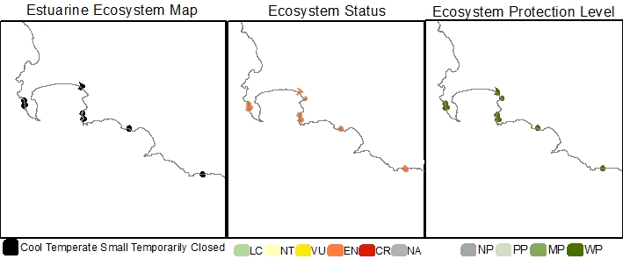
Estuarine Ecosystem type | Cool Temperate Small Temporarily Closed
Ecosystem ID | To be provided by SANBI
NBA 2018 Coastal Classification | Coastal Classification NCM NBA2018 - To be provided by SANBI
Ecosystem type version history | 2018☒ 2024☐
Biogeographical Region | Cool Temperate
Ecosystem Threat Status (IUCN RLE v1.1): | Endangered
Assesment findings | Cool Temperate Small Temporarily Closed are experiencing historical reductions in geographic range. Due to ongoing urbanisation this trend is likely to continue. These systems are also threatened by ongoing environmental degradation, specifically from pollution, land-use change, water abstraction, and biological invasions pressures.
Trigger criteria: | A3 – historical and future reductions in geographic range
Other criteria considered: | C3 – Environmental degradation since 1750  B3 – Restricted geographic range
Assessment Scope: | National
Assessment type: | Systematic assessment
Date assessed: | 2018/2019
Year published: | 2020
Provincial distribution: | Western Cape
Historical extent (km²): | 5.5
Remaining natural extent (%): | 28 % Natural & 18% Near-natural
Conservation Target | 1.1 km² - 20 % (new ecosystem type, not included in 2011 National Estuaries Biodiversity Plan)
Area protected | 38 %
Area under very high & high fishing pressure | 0 %
Protection level from National Biodiversity Assessment 2018: | Well protected
Ecosystem description: | The large temporarily open/closed category of Whitfield (1992) was divided into Small and Large Temporarily Closed estuaries in 2019 using a total habitat area of 15ha (associated with ~10ha of open water area) as the dividing threshold. The division was based on differences in biophysical processes and patterns. Small temporarily closed systems are likely to experience rapid increases and decreases freshwater runoff over a few hours making them strongly event-driven. As a result of there small volume there are little scouring during breachings, and a semi-closed mouth condition can easily develop owing to a small, perched, outflow channel that restricts tidal amplitude to 10 to 15cm. There is also minimal water column area during the open state. Habitat diversity is low (no intertidal salt marshes) and species diversity and abundance reduced. Similarly fish assemblages are limited to a few species. Systems tend to be linear or funnel-shaped with highly restricted inlets. Smaller systems especially tend to be ‘perched’ above normal tidal levels, resulting in little to no open water area during the open mouth low tide state. Water levels are dominated by the state of the mouth, with highest levels of 1 m to 2 m above mean sea level during the closed phase. Tidal ranges are very restricted, ranging between 15-30 cm in Small Temporarily Closed estuaries. Open phase mixing processes are dominated by fluvial input and partially by tides. When closed, wind and seepage losses through the berm play a key role. Sediment composition is largely stable, resetting mainly during floods. Small Temporarily Closed estuaries tend to be fresher in character than Large Temporarily Closed as they have less connectivity with the sea.
Rain season: | Winter
Altitude: | Between 0 masl and 5 masl.
Mean Annual Runoff: | 0.14 to 66.3 x10⁶ m³/annum
Temperature: | Average monthly maximum in summer is between 19-21 °C and Average monthly minimum in winter is between 12 and 13°C.
Endemic taxa
Economically important taxa
Ecologically important taxa
Endemic taxa
Primary threatening processes: | 38% of ecosystem extent under severe pollution pressure (very high to high levels) from Wastewater Treatment works, urban storm water and agricultural return flow.  38% of ecosystem extent is under severe land-use change and development (mostly urban development and agriculture) pressure  26% of ecosystem extent is under severe alien/extralimital fish pressure causing disruption of pattern and process in fresher and brackish zones.  25% of ecosystem extent is under severe alien invasive plant pressure in one or more of their reaches.  13% of ecosystem extent is under severe flow modification pressure.  Little fishing pressure.
Limitations and knowledge gaps | While the condition assessments for most systems have been updated, the under-pinning survey data is between 20 and 30 years old. It is therefore of critical importance that more up to date nation-wide surveys be conducted to improve our overall confidence in the estimated change for the different ecosystem types and to inform future assessments.  Estuaries are interconnected over local, bioregional and global scales. Ecosystems threat status are just one of a range of measures that document the decline in condition and the response to an escalating human footprint. The results of the ecosystem threat status assessment should not be decoupled from the overall regional findings and the deeply concerning trend of large gaps in functioning estuaries due to collective poor condition along urban coastlines.
Estuaries in Ecosystem (estuary ID) | Schuster (17)  Krom (18)  Lourens (23)  Sir LowryΓÇÖs Pass (24)  Rooiels (26)  Buffels (Oos) (27)  Onrus (30)  Ratel (33)
Assessors | Van Niekerk, L., Adams, J.B., Lamberth, S.J., Turpie, J., MacKay, F., Sink, K. & Skowno, A.L
Reviewers | National Biodiversity Assessment Estuaries Reference Group (2016-2019) (2018 version).
Data sources | Dayaram, A., Skowno, A.L., Driver, A., Sink, K., Van Deventer, H., Smith-Adao, L., Van Niekerk, L., Harris, L.R., Job, N. & Nel, J.L. 2021. The South African National Ecosystem Classification System Handbook: First Edition. South African National Biodiversity Institute, Pretoria, South Africa. http://hdl.handle.net/20.500.12143/7150  GeoTerraImage (2015) Technical Report: 1990 South African National Land Cover Dataset version 5.2. Pretoria, 63 pp. SANBI Threatened Species Unit pers com (2020) Threatened plant species database of South Africa.  Van Niekerk, L, Adams JB, James, N, Lamberth S, Mackay F, Rajkaran A, Turpie J, Weerts S, Whitfield AK. 2020. An Estuary Ecosystem Classification that encompasses biogeography and a high diversity of types in support of protection and management. African Journal of Aquatic Science, 45: 199-216.  Van Niekerk, L., Adams, J.B., Lamberth, S.J., Turpie, J., MacKay, F., Sink, K. & Skowno, A.L., 2019, ‘Chapter 8: Ecosystem Threat Status and Protection levels’ in South African National Biodiversity Assessment 2018: Technical Report. Volume 3: Estuarine Realm. CSIR report number CSIR/SPLA/EM/EXP/2019/0062/A. South African National Biodiversity Institute, Pretoria. Report Number: http://hdl.handle.net/20.500.12143/6373.
Author (s) of Factsheet | Van Niekerk, L., Adams, J.B., Lamberth, Dayaram, A.
Recommended Citation | South African National Biodiversity Institute (2022-). [Name], Online, webpage link (unknown), accessed on [download date]
Image | [Link to images of ecosystem if available].*

Warm Temperate Estuarine Bay

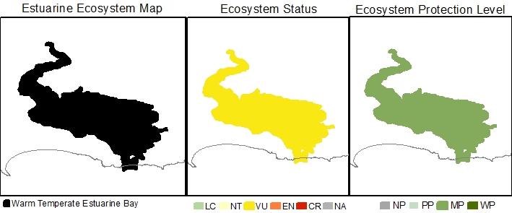
Estuarine Ecosystem type | Warm Temperate Estuarine Bay
Ecosystem ID | To be provided by SANBI
NBA 2018 Coastal Classification | Coastal Classification NCM NBA2018 - To be provided by SANBI
Ecosystem type version history | 2018☐ 2024☐
Biogeographical Region | Warm Temperate
Ecosystem Threat Status (IUCN RLE v1.1): | Vulnerable
Assesment findings | The Warm Temperate Knysna Estuarine Bay are one of a kind, unique estuarine type in South Africa, which is also experiencing historical reductions in geographic range. Due to ongoing urbanisation this trend is likely to continue. These systems are also threatened by ongoing environmental degradation, specifically from pollution, land-use change, over exploitation of living resources, and biological invasions pressures.
Trigger criteria: | A3 – historical and future reductions in geographic range  B3 – Restricted geographic range
Other criteria considered: | C3 – Environmental degradation since 1750
Assessment Scope: | National
Assessment type: | Systematic assessment
Date assessed: | 2018/2019
Year published: | 2020
Provincial distribution: | Western Cape
Historical extent (km²): | 14.4
Remaining natural extent (%): | 100%
Conservation Target | 6.0 km² - 20 % (new ecosystem type, not included in 2011 National Estuaries Biodiversity Plan)
Area protected | 99%
Area under very high & high fishing pressure | 100 % triggering downgrade to Moderately protected
Protection level from National Biodiversity Assessment 2018: | Moderately protected
Ecosystem description: | Estuarine Bays are permanently linked to the sea by unrestricted, deep mouths and are dominated by tidal processes, with tidal amplitudes close to those of the sea. Members of this ecosystem type are large systems (>1200 ha) with generally round basins where only the upper reaches experience a degree of constriction to tidal flows. As a result of relatively low river inputs they have a predominantly euhaline salinity regime in the lower and mid reaches, with freshwater mixing processes being mostly confined to the restricted upper areas. Sediments are typically marine in origin and grain size distributions are stable. There are only two natural occurrences of Estuarine Bays in South Africa (viz. Knysna (Warm Temperate) and Durban Bay (Subtropical).
Rain season: | All year
Altitude: | Between 0 masl and 5 masl.
Mean Annual Runoff: | 83.2 x10⁶ m³/annum
Temperature: | Average monthly maximum in summer is 19 °C and Average monthly minimum in winter is 14 °C.
Endemic taxa
Economically important taxa
Ecologically important taxa
Primary threatening processes: | 100% of ecosystem extent under severe pollution pressure (very high to high levels) from Wastewater Treatment works, urban storm water and agricultural return flow.  100% of ecosystem extent is under severe fishing pressure.  100% of ecosystem extent is under severe land-use change and infrastructure development.  100% of ecosystem extent is under severe alien/extralimital fish pressure causing disruption of pattern and process in fresher and brackish zones.
Limitations and knowledge gaps | While the condition assessments for most systems have been updated, the under-pinning survey data is between 20 and 30 years old. It is therefore of critical importance that more up to date nation-wide surveys be conducted to improve our overall confidence in the estimated change for the different ecosystem types and to inform future assessments.  Estuaries are interconnected over local, bioregional and global scales. Ecosystems threat status are just one of a range of measures that document the decline in condition and the response to an escalating human footprint. The results of the ecosystem threat status assessment should not be decoupled from the overall regional findings and the deeply concerning trend of large gaps in functioning estuaries due to collective poor condition along urban coastlines.
Estuaries in Ecosystem (estuary ID) | Knysna (52)
Assessors | Van Niekerk, L., Adams, J.B., Lamberth, S.J., Turpie, J., MacKay, F., Sink, K. & Skowno, A.L
Reviewers | National Biodiversity Assessment Estuaries Reference Group (2016-2019) (2018 version).
Data sources | Dayaram, A., Skowno, A.L., Driver, A., Sink, K., Van Deventer, H., Smith-Adao, L., Van Niekerk, L., Harris, L.R., Job, N. & Nel, J.L. 2021. The South African National Ecosystem Classification System Handbook: First Edition. South African National Biodiversity Institute, Pretoria, South Africa. http://hdl.handle.net/20.500.12143/7150  GeoTerraImage (2015) Technical Report: 1990 South African National Land Cover Dataset version 5.2. Pretoria, 63 pp. SANBI Threatened Species Unit pers com (2020) Threatened plant species database of South Africa.  Van Niekerk, L, Adams JB, James, N, Lamberth S, Mackay F, Rajkaran A, Turpie J, Weerts S, Whitfield AK. 2020. An Estuary Ecosystem Classification that encompasses biogeography and a high diversity of types in support of protection and management. African Journal of Aquatic Science, 45: 199-216.  Van Niekerk, L., Adams, J.B., Lamberth, S.J., Turpie, J., MacKay, F., Sink, K. & Skowno, A.L., 2019, ‘Chapter 8: Ecosystem Threat Status and Protection levels’ in South African National Biodiversity Assessment 2018: Technical Report. Volume 3: Estuarine Realm. CSIR report number CSIR/SPLA/EM/EXP/2019/0062/A. South African National Biodiversity Institute, Pretoria. Report Number: http://hdl.handle.net/20.500.12143/6373.
Author (s) of Factsheet | Van Niekerk, L., Adams, J.B., Lamberth, Dayaram, A.
Recommended Citation | South African National Biodiversity Institute (2022-). [Name], Online, webpage link (unknown), accessed on [download date]
Image | [Link to images of ecosystem if available].*

Warm Temperate Estuarine Lake

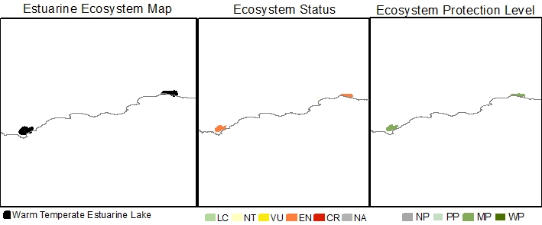
Estuarine Ecosystem type | Warm Temperate Estuarine Lake
Ecosystem ID | To be provided by SANBI
NBA 2018 Coastal Classification | Coastal Classification NCM NBA2018 - To be provided by SANBI
Ecosystem type version history | 2018☒ 2024☐
Biogeographical Region | Warm Temperate
Ecosystem Threat Status (IUCN RLE v1.1): | Endangered
Assesment findings | The Warm Temperate Estuarine Lakes are experiencing historical reductions in geographic range. These systems are also threatened by ongoing environmental degradation, specifically from land-use change, mouth manipulation, over exploitation of living resources, and biological invasions pressures.
Trigger criteria: | A3 – historical and future reductions in geographic range
Other criteria considered: | C3 – Environmental degradation since 1750  B3 – Restricted geographic range
Assessment Scope: | National
Assessment type: | Systematic assessment
Date assessed: | 2018/2019
Year published: | 2020
Provincial distribution: | Western Cape
Historical extent (km²): | 143.9
Remaining natural extent (%): | 15% Near Natural
Conservation Target | 28.8 km² - 20 %
Area protected | 31 %
Area under very high & high fishing pressure | 0 %
Protection level from National Biodiversity Assessment 2018: | Moderately protected
Ecosystem description: | Estuarine Lake ecosystems comprise one or more large circular water bodies connected to the sea by a constricted inlet channel (Whitfield 1992; Van Niekerk et al., 2020). Maximum water levels are determined by berm height, mouth state (open/close) and freshwater input. Marine connectivity varies from almost permanently open to closed on annual scales. Salinities are highly variable, ranging from fresh to hypersaline because of differing freshwater input (surface and groundwater), evaporation and the extent of the marine connection (. Mixing processes are dominated by wind and, to a lesser extent fluvial inputs, owing to their restricted mouths and relatively large surface areas. Average tidal amplitudes are negligible (15 – 20 cm) when connected to the sea, primarily due to restricted mouth conditions. Sediment processes tend to be stable, with infilling occurring over long time scales and resetting confined to larger flood events.
Rain season: | Winter or All year
Altitude: | Between 0 masl and 5 masl.
Mean Annual Runoff: | 29.7 to 83.15 x10⁶ m³/annum
Temperature: | Average monthly maximum in summer is between 19 and 21 °C and Average monthly minimum in winter is between 13 and 14°C.
Endemic taxa
Economically important taxa
Ecologically important taxa
Endemic taxa
Primary threatening processes: | 33% of ecosystem extent is under severe (high to very high) land-use change (mostly urban development and agriculture) pressure  33% of ecosystem extent is under severe mouth manipulation pressure.  33% of ecosystem extent is under severe alien/extralimital fish pressure causing disruption of pattern and process in fresher and brackish zones.
Limitations and knowledge gaps | While the condition assessments for most systems have been updated, the under-pinning survey data is between 20 and 30 years old. It is therefore of critical importance that more up to date nation-wide surveys be conducted to improve our overall confidence in the estimated change for the different ecosystem types and to inform future assessments.  Estuaries are interconnected over local, bioregional and global scales. Ecosystems threat status are just one of a range of measures that document the decline in condition and the response to an escalating human footprint. The results of the ecosystem threat status assessment should not be decoupled from the overall regional findings and the deeply concerning trend of large gaps in functioning estuaries due to collective poor condition along urban coastlines.
Estuaries in Ecosystem (estuary ID) | Heuningnes (34)  Touw/Wilderness (49)  Swartvlei (50)
Assessors | Van Niekerk, L., Adams, J.B., Lamberth, S.J., Turpie, J., MacKay, F., Sink, K. & Skowno, A.L
Reviewers | National Biodiversity Assessment Estuaries Reference Group (2016-2019) (2018 version).
Data sources | Dayaram, A., Skowno, A.L., Driver, A., Sink, K., Van Deventer, H., Smith-Adao, L., Van Niekerk, L., Harris, L.R., Job, N. & Nel, J.L. 2021. The South African National Ecosystem Classification System Handbook: First Edition. South African National Biodiversity Institute, Pretoria, South Africa. http://hdl.handle.net/20.500.12143/7150  GeoTerraImage (2015) Technical Report: 1990 South African National Land Cover Dataset version 5.2. Pretoria, 63 pp. SANBI Threatened Species Unit pers com (2020) Threatened plant species database of South Africa.  Van Niekerk, L, Adams JB, James, N, Lamberth S, Mackay F, Rajkaran A, Turpie J, Weerts S, Whitfield AK. 2020. An Estuary Ecosystem Classification that encompasses biogeography and a high diversity of types in support of protection and management. African Journal of Aquatic Science, 45: 199-216.  Van Niekerk, L., Adams, J.B., Lamberth, S.J., Turpie, J., MacKay, F., Sink, K. & Skowno, A.L., 2019, ‘Chapter 8: Ecosystem Threat Status and Protection levels’ in South African National Biodiversity Assessment 2018: Technical Report. Volume 3: Estuarine Realm. CSIR report number CSIR/SPLA/EM/EXP/2019/0062/A. South African National Biodiversity Institute, Pretoria. Report Number: http://hdl.handle.net/20.500.12143/6373.
Author (s) of Factsheet | Van Niekerk, L., Adams, J.B., Lamberth, Dayaram, A.
Recommended Citation | South African National Biodiversity Institute (2022-). [Name], Online, webpage link (unknown), accessed on [download date]
Image | [Link to images of ecosystem if available].*

Warm Temperate Large Fluvially Dominated

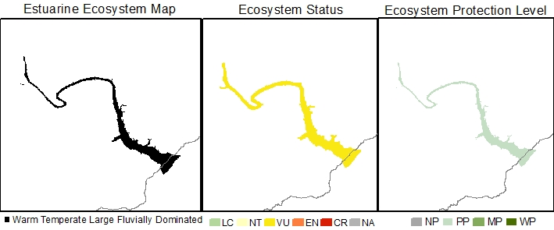
Estuarine Ecosystem type | Warm Temperate Large Fluvially Dominated
Ecosystem ID | To be provided by SANBI
NBA 2018 Coastal Classification | Coastal Classification NCM NBA2018 - To be provided by SANBI
Ecosystem type version history | 2018☐ 2024☐
Biogeographical Region | Warm Temperate
Ecosystem Threat Status (IUCN RLE v1.1): | Vulnerable
Assesment findings | The Warm Temperate Large Fluvially Dominated Great Kei are one of a kind, unique estuarine type in South Africa. This ecosystem types is also are threatened by ongoing environmental degradation, specifically from water abstraction, over exploitation of living resources and biological invasions pressures.
Trigger criteria: | C3 – Environmental degradation since 1750  B3 – Restricted geographic range
Other criteria considered: | A3 – historical and future reductions in geographic range
Assessment Scope: | National
Assessment type: | Systematic assessment
Date assessed: | 2018/2019
Year published: | 2020
Provincial distribution: | Eastern Cape
Historical extent (km²): | 5.7
Remaining natural extent (%): | 0%
Conservation Target | 1.1 km² - 20 % (new ecosystem type, not included in 2011 National Estuaries Biodiversity Plan)
Area protected | 3%
Area under very high & high fishing pressure | 0 %
Protection level from National Biodiversity Assessment 2018: | Poorly protected
Ecosystem description: | Large Fluvially Dominated estuaries are large, shallow, sediment-rich, freshwater dominated systems with a very high sediment turnover, often develop ebb-tidal deltas, are turbid and can close during periods of low flow, e.g. uThukela and Orange estuaries. Estuary mouths tend to be constricted and can even periodically close during low flows. River processes are dominant, and salinities are mostly fresh throughout the estuary for more than half the time. During peak flood conditions, outflows can influence salinities for considerable distances offshore. Fluvially Dominated systems was previous characterised as river mouths by Whitfield (1992).
Rain season: | Late Summer
Altitude: | Between 0 masl and 5 masl.
Mean Annual Runoff: | 954.9 x10⁶ m³/annum
Temperature: | Average monthly maximum in summer is 21 °C and Average monthly minimum in winter is 15°C.
Endemic taxa
Economically important taxa
Ecologically important taxa
Endemic taxa
Primary threatening processes: | 100% of ecosystem extent under severe flow modification pressure (very high to high levels);  100% of ecosystem extent is under severe fishing pressure.  100% of ecosystem extent is under severe alien/extralimital fish pressure causing disruption of pattern and process in fresher and brackish zones.
Limitations and knowledge gaps | While the condition assessments for most systems have been updated, the under-pinning survey data is between 20 and 30 years old. It is therefore of critical importance that more up to date nation-wide surveys be conducted to improve our overall confidence in the estimated change for the different ecosystem types and to inform future assessments.  Estuaries are interconnected over local, bioregional and global scales. Ecosystems threat status are just one of a range of measures that document the decline in condition and the response to an escalating human footprint. The results of the ecosystem threat status assessment should not be decoupled from the overall regional findings and the deeply concerning trend of large gaps in functioning estuaries due to collective poor condition along urban coastlines.
Estuaries in Ecosystem (estuary ID) | Great Kei (131)
Assessors | Van Niekerk, L., Adams, J.B., Lamberth, S.J., Turpie, J., MacKay, F., Sink, K. & Skowno, A.L
Reviewers | National Biodiversity Assessment Estuaries Reference Group (2016-2019) (2018 version).
Data sources | Dayaram, A., Skowno, A.L., Driver, A., Sink, K., Van Deventer, H., Smith-Adao, L., Van Niekerk, L., Harris, L.R., Job, N. & Nel, J.L. 2021. The South African National Ecosystem Classification System Handbook: First Edition. South African National Biodiversity Institute, Pretoria, South Africa. http://hdl.handle.net/20.500.12143/7150  GeoTerraImage (2015) Technical Report: 1990 South African National Land Cover Dataset version 5.2. Pretoria, 63 pp. SANBI Threatened Species Unit pers com (2020) Threatened plant species database of South Africa.  Van Niekerk, L, Adams JB, James, N, Lamberth S, Mackay F, Rajkaran A, Turpie J, Weerts S, Whitfield AK. 2020. An Estuary Ecosystem Classification that encompasses biogeography and a high diversity of types in support of protection and management. African Journal of Aquatic Science, 45: 199-216.  Van Niekerk, L., Adams, J.B., Lamberth, S.J., Turpie, J., MacKay, F., Sink, K. & Skowno, A.L., 2019, ‘Chapter 8: Ecosystem Threat Status and Protection levels’ in South African National Biodiversity Assessment 2018: Technical Report. Volume 3: Estuarine Realm. CSIR report number CSIR/SPLA/EM/EXP/2019/0062/A. South African National Biodiversity Institute, Pretoria. Report Number: http://hdl.handle.net/20.500.12143/6373.
Author (s) of Factsheet | Van Niekerk, L., Adams, J.B., Lamberth, Dayaram, A.,
Recommended Citation | South African National Biodiversity Institute (2022-). [Name], Online, webpage link (unknown), accessed on [download date]
Image | [Link to images of ecosystem if available].*

Warm Temperate Large Temporarily Closed

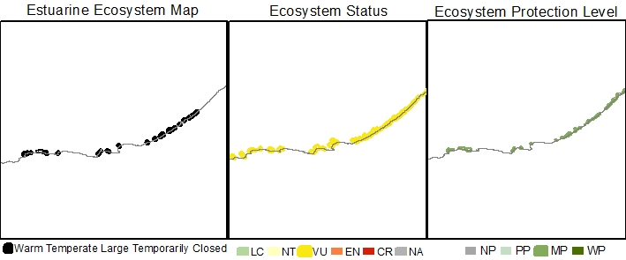
Estuarine Ecosystem type | Warm Temperate Large Temporarily Closed
Ecosystem ID | To be provided by SANBI
NBA 2018 Coastal Classification | Coastal Classification NCM NBA2018 - To be provided by SANBI
Ecosystem type version history | 2018☐ 2024☐
Biogeographical Region | Warm Temperate
Ecosystem Threat Status (IUCN RLE v1.1): | Vulnerable
Assesment findings | Warm Temperate Large Temporarily Closed estuaries are threatened by ongoing environmental degradation, specifically from increasing pressure from land-use change, water abstraction, pollution, mouth manipulations, over exploitation of living resources and biological invasions. These systems are also experiencing historical reductions in geographic range. Due to ongoing urbanisation this trend is likely to continue.
Trigger criteria: | C3 – Environmental degradation since 1750  A3 – historical and future reductions in geographic range
Other criteria considered: | B3 – Restricted geographic range
Assessment Scope: | National
Assessment type: | Systematic assessment
Date assessed: | 2018/2019
Year published: | 2020
Provincial distribution: | Western Cape and Eastern Cape
Historical extent (km²): | 70.0
Remaining natural extent (%): | 10% Natural & 48% Near Natural
Conservation Target | 14.0 km² - 20 % (new ecosystem type, not included in 2011 National Estuaries Biodiversity Plan)
Area protected | 12%
Natural Area under very high & high fishing pressure | 10 % Natural & 48% Near Natural
Protection level from National Biodiversity Assessment 2018: | Moderately protected
Ecosystem description: | The extensive temporarily open/closed category of Whitfield (1992) was divided into Large and Small Temporarily Closed estuaries in 2019 using a total habitat area of 15ha (associated with ~10ha of open water area) as the dividing threshold. The division was based on differences in biophysical processes and patterns. Large temporarily closed systems are likely to experience increases and decreases freshwater runoff over hours to days making them highly responsive to changes in runoff. Systems tend to be linear or funnel-shaped with highly restricted inlets. Systems along exposed coastlines especially tend to be ‘perched’ above normal tidal levels, resulting in limited open water area during the open mouth low tide state. Water levels are dominated by the state of the mouth, with highest levels of 1 m to 2 m above mean sea level during the closed phase. Tidal ranges are very restricted, ranging between 25-50 cm. During the open phase mixing processes are dominated by fluvial input and partially by tides. When closed, wind and seepage losses through the berm play a key role. Sediment composition is largely stable, resetting mainly during floods and partially during breaching of the mouth. Salinity regimes range from almost fresh to hypersaline, which can develop during times of low flow or droughts.
Rain season: | All year, Early to Late summer
Altitude: | Between 0 masl and 5 masl.
Mean Annual Runoff: | 1.1 to 57.5 x10⁶ m³/annum
Temperature: | Average monthly maximum in summer is between 19 and 22°C and Average monthly minimum in winter is between 14 and 16°C.
Endemic taxa
Economically important taxa
Ecologically important taxa
Endemic taxa
Primary threatening processes: | 15% of ecosystem extent is under severe land-use change (mostly urban development and agriculture) pressure;  13% of ecosystem extent under severe flow modification pressure from Wastewater Treatment works, urban storm water and agricultural return flow.  10% of ecosystem extent is under severe fishing and pollution pressure, respectively.  10% of ecosystem extent is under severe mouth manipulation pressure.  18% of ecosystem extent is under severe alien/extralimital fish pressure causing disruption of pattern and process in fresher and brackish zones.  18% of ecosystem extent is under severe alien invasive plant pressure in one or more of their reaches.
Limitations and knowledge gaps | While the condition assessments for most systems have been updated, the under-pinning survey data is between 20 and 30 years old. It is therefore of critical importance that more up to date nation-wide surveys be conducted to improve our overall confidence in the estimated change for the different ecosystem types and to inform future assessments.  Estuaries are interconnected over local, bioregional and global scales. Ecosystems threat status are just one of a range of measures that document the decline in condition and the response to an escalating human footprint. The results of the ecosystem threat status assessment should not be decoupled from the overall regional findings and the deeply concerning trend of large gaps in functioning estuaries due to collective poor condition along urban coastlines.
Estuaries in Ecosystem (estuary ID) | Hartenbos (43)  Klein Brak (44)  Groot Brak (45)  Maalgate (46)  Goukamma (51)  Piesang (54)  Seekoei (69)  Kabeljous (70)  Van Stadens (72)  Maitland (73)  Coega (Ngqurha) (77)  Kasouga (83)  West Kleinemonde (87)  East Kleinemonde (88)  Old WomanΓÇÖs (90)  Mpekweni (91)  Mtati (Mthathi) (92)  Mgwalana (93)  Bira (Bhirha) (94)  Gqutywa (95)  Kiwane (Khiwane) (100)  Tyolomnqa (101)  Ncera (Ncerha) (105)  Gxulu (108)  Goda (109)  Qinira (Quinirha) (116)  Bulura (Bulurha) (119)  Cintsa (121)  Cefane (122)  Kwenxura (Kwenxurha) (123)  Nyara (Nyarha) (124)  Quko (128)  Morgan (129)  Gxara (Gxarha) (132)  Qolora (Qolorha) (134)  Nxaxo/Ngqusi (138)  Cebe (139)  Gqunqe (140)  Ngqwara (Ngqwarha) (142)  Mendu (156)
Assessors | Van Niekerk, L., Adams, J.B., Lamberth, S.J., Turpie, J., MacKay, F., Sink, K. & Skowno, A.L
Reviewers | National Biodiversity Assessment Estuaries Reference Group (2016-2019) (2018 version).
Data sources | Dayaram, A., Skowno, A.L., Driver, A., Sink, K., Van Deventer, H., Smith-Adao, L., Van Niekerk, L., Harris, L.R., Job, N. & Nel, J.L. 2021. The South African National Ecosystem Classification System Handbook: First Edition. South African National Biodiversity Institute, Pretoria, South Africa. http://hdl.handle.net/20.500.12143/7150  GeoTerraImage (2015) Technical Report: 1990 South African National Land Cover Dataset version 5.2. Pretoria, 63 pp. SANBI Threatened Species Unit pers com (2020) Threatened plant species database of South Africa.  Van Niekerk, L, Adams JB, James, N, Lamberth S, Mackay F, Rajkaran A, Turpie J, Weerts S, Whitfield AK. 2020. An Estuary Ecosystem Classification that encompasses biogeography and a high diversity of types in support of protection and management. African Journal of Aquatic Science, 45: 199-216.  Van Niekerk, L., Adams, J.B., Lamberth, S.J., Turpie, J., MacKay, F., Sink, K. & Skowno, A.L., 2019, ‘Chapter 8: Ecosystem Threat Status and Protection levels’ in South African National Biodiversity Assessment 2018: Technical Report. Volume 3: Estuarine Realm. CSIR report number CSIR/SPLA/EM/EXP/2019/0062/A. South African National Biodiversity Institute, Pretoria. Report Number: http://hdl.handle.net/20.500.12143/6373.
Author (s) of Factsheet | Van Niekerk, L., Adams, J.B., Lamberth, Dayaram, A.
Recommended Citation | South African National Biodiversity Institute (2022-). [Name], Online, webpage link (unknown), accessed on [download date]
Image | [Link to images of ecosystem if available].*

Warm Temperate Predominantly Open

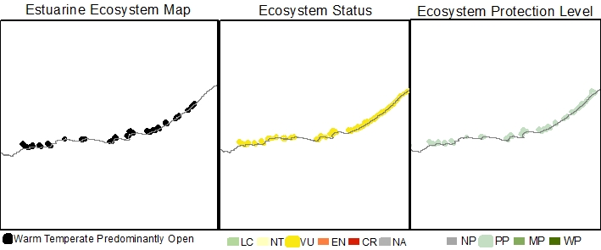
Estuarine Ecosystem type | Warm Temperate Predominantly Open
Ecosystem ID | To be provided by SANBI
NBA 2018 Coastal Classification | Coastal Classification NCM NBA2018 - To be provided by SANBI
Ecosystem type version history | 2018☐ 2024☐
Biogeographical Region | Warm Temperate
Ecosystem Threat Status (IUCN RLE v1.1): | Vulnerable
Assesment findings | Warm Temperate Predominantly Open estuaries threatened by ongoing environmental degradation, specifically from increasing pressure from land-use change, over exploitation of living resources, water abstraction, pollution, mouth manipulations, and biological invasions. These systems are also experiencing historical reductions in geographic range. Due to ongoing urbanisation this trend is likely to continue.
Trigger criteria: | C3 – Environmental degradation since 1750  A3 – historical and future reductions in geographic range
Other criteria considered: | B3 – Restricted geographic range
Assessment Scope: | National
Assessment type: | Systematic assessment
Date assessed: | 2018/2019
Year published: | 2020
Provincial distribution: | Western Cape and Eastern Cape
Historical extent (km²): | 177.8
Remaining natural extent (%): | 3% Natural & 50 %Near Natural
Conservation Target | 35.6 km² - 20 %
Area protected | 14 %
Natural Area under very high & high fishing pressure | 1 %
Protection level from National Biodiversity Assessment 2018: | Poorly protected
Ecosystem description: | Estuaries in this ecosystem type are open to the sea for more than 90% of the time (Whitfield 1992; Van Niekerk et al. 2019; 2020). Some are permanently open owing to perennial river flows or the presence of large tidal prisms. Tidal amplitude ranges from 0.75-1.5 m. Predominantly Open estuaries are linear systems in which mixing processes are dominated by both fluvial inputs and tidal action creating vertical and horizontal salinity gradients. Under low flows, hypersalinity can develop in the upper reaches of the temperate systems.  The degree to which the mouth is restricted depends on the rate and volume of freshwater inflow. Some systems become severely constricted during low flow periods, decreasing the tidal amplitude and increasing the duration of the ebb-tidal cycle. Regular flooding results in relatively mobile sediments. Surprisingly, their size varies considerably, with smaller systems afforded a degree of protection against direct wave action by rocky headlands or subtidal reefs, which assists in maintaining an open mouth.
Rain season: | Winter, All year, and Late Summer to Very Late summer
Altitude: | Between 0 masl and 5 masl.
Mean Annual Runoff: | 1.35 to 1785.0 x10⁶ m³/annum
Temperature: | Average monthly maximum in summer is between 19 and 22 °C and Average monthly minimum in winter is between 12 and 17°C.
Endemic taxa
Economically important taxa
Ecologically important taxa
Endemic taxa
Primary threatening processes: | 64% of ecosystem extent under severe fishing pressure (very high to high levels).  32% of ecosystem extent is under severe flow modification pressure.  28% of ecosystem extent is under severe land-use change (mostly urban development and agriculture) pressure  24% of ecosystem extent under severe pollution pressure from Wastewater Treatment works, urban storm water and agricultural return flow.  64% of ecosystem extent is under severe alien/extralimital fish pressure causing disruption of pattern and process in fresher and brackish zones.  20% of ecosystem extent is under severe alien invasive plant pressure in one or more of their reaches.
Limitations and knowledge gaps | While the condition assessments for most systems have been updated, the under-pinning survey data is between 20 and 30 years old. It is therefore of critical importance that more up to date nation-wide surveys be conducted to improve our overall confidence in the estimated change for the different ecosystem types and to inform future assessments.  Estuaries are interconnected over local, bioregional and global scales. Ecosystems threat status are just one of a range of measures that document the decline in condition and the response to an escalating human footprint. The results of the ecosystem threat status assessment should not be decoupled from the overall regional findings and the deeply concerning trend of large gaps in functioning estuaries due to collective poor condition along urban coastlines.
Estuaries in Ecosystem (estuary ID) | Breede (36)  Duiwenhoks (37)  Goukou (38)  Gouritz (39)  Kaaimans (48)  Keurbooms (55)  Sout (Oos) (57)  Kromme (68)  Gamtoos (71)  Swartkops (76)  Sundays (78)  Bushmans (80)  Kariega (81)  Kowie (84)  Great Fish (89)  Keiskamma (98)  Buffalo (112)  Nahoon (115)  Gqunube (117)  Kwelera (Kwelerha) (118)  Kobonqaba (Khobonqaba) (137)  Qora (Qhorha) (145)  Shixini (148)  Nqabara/Nqabarana (153)  Mendwana (157)
Assessors | Van Niekerk, L., Adams, J.B., Lamberth, S.J., Turpie, J., MacKay, F., Sink, K. & Skowno, A.L
Reviewers | National Biodiversity Assessment Estuaries Reference Group (2016-2019) (2018 version).
Data sources | Dayaram, A., Skowno, A.L., Driver, A., Sink, K., Van Deventer, H., Smith-Adao, L., Van Niekerk, L., Harris, L.R., Job, N. & Nel, J.L. 2021. The South African National Ecosystem Classification System Handbook: First Edition. South African National Biodiversity Institute, Pretoria, South Africa. http://hdl.handle.net/20.500.12143/7150  GeoTerraImage (2015) Technical Report: 1990 South African National Land Cover Dataset version 5.2. Pretoria, 63 pp. SANBI Threatened Species Unit pers com (2020) Threatened plant species database of South Africa.  Van Niekerk, L, Adams JB, James, N, Lamberth S, Mackay F, Rajkaran A, Turpie J, Weerts S, Whitfield AK. 2020. An Estuary Ecosystem Classification that encompasses biogeography and a high diversity of types in support of protection and management. African Journal of Aquatic Science, 45: 199-216.  Van Niekerk, L., Adams, J.B., Lamberth, S.J., Turpie, J., MacKay, F., Sink, K. & Skowno, A.L., 2019, ‘Chapter 8: Ecosystem Threat Status and Protection levels’ in South African National Biodiversity Assessment 2018: Technical Report. Volume 3: Estuarine Realm. CSIR report number CSIR/SPLA/EM/EXP/2019/0062/A. South African National Biodiversity Institute, Pretoria. Report Number: http://hdl.handle.net/20.500.12143/6373.
Author (s) of Factsheet | Van Niekerk, L., Adams, J.B., Lamberth, Dayaram, A.
Recommended Citation | South African National Biodiversity Institute (2022-). [Name], Online, webpage link (unknown), accessed on [download date]
Image | [Link to images of ecosystem if available].*

Warm Temperate Small Fluvially Dominated

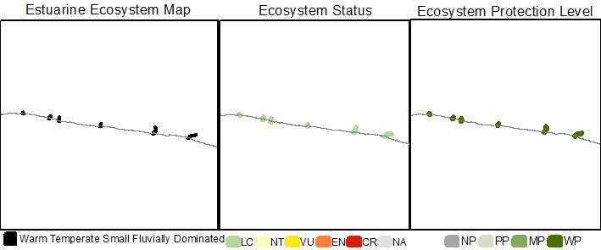
Estuarine Ecosystem type | Warm Temperate Small Fluvially Dominated
Ecosystem ID | To be provided by SANBI
NBA 2018 Coastal Classification | Coastal Classification NCM NBA2018 - To be provided by SANBI
Ecosystem type version history | 2018☐ 2024☐
Biogeographical Region | Warm Temperate
Ecosystem Threat Status (IUCN RLE v1.1): | Least Concern
Assesment findings | Currently there are no substantial, known biotic disruptions or pressures, as such it is considered Least Concern.
Trigger criteria: | -
Other criteria considered: | C3 – Environmental degradation since 1750  A3 – historical and future reductions in geographic range  B3 – Restricted geographic range
Assessment Scope: | National
Assessment type: | Systematic assessment
Date assessed: | 2018/2019
Year published: | 2020
Provincial distribution: | Western Cape and Eastern Cape
Historical extent (km²): | 1.2
Remaining natural extent (%): | 75 %Natural & 25% Near Natural
Conservation Target | 0.2 km² - 20 % (new ecosystem type, not included in 2011 National Estuaries Biodiversity Plan)
Area protected | 83%
Area under very high & high fishing pressure | 0 %
Protection level from National Biodiversity Assessment 2018: | Well protected
Ecosystem description: | Small Fluvially Dominated systems are small (<15 ha), sediment-starved, fluvially-dominated systems that have unrestricted mouths as they usually occur along rocky shores and receive clear humic-stained water from Table Mountain Sandstone catchments (Van Niekerk et al., 2019; 2020). Fluvially Dominated systems was previous characterised as river mouths by Whitfield (1992).
Rain season: | All Year
Altitude: | Between 0 masl and 5 masl.
Mean Annual Runoff: | 18.5 to 54.1 x10⁶ m³/annum
Temperature: | Average monthly maximum in summer is between 20 and 22 °C and Average monthly minimum in winter is between 14 and 15°C.
Endemic taxa
Economically important taxa
Ecologically important taxa
Endemic taxa
Primary threatening processes: | No severe pressures on this ecosystem type, but flow modification and pollution pose a risk.
Limitations and knowledge gaps | While the condition assessments for most systems have been updated, the under-pinning survey data is between 20 and 30 years old. It is therefore of critical importance that more up to date nation-wide surveys be conducted to improve our overall confidence in the estimated change for the different ecosystem types and to inform future assessments.  Estuaries are interconnected over local, bioregional and global scales. Ecosystems threat status are just one of a range of measures that document the decline in condition and the response to an escalating human footprint. The results of the ecosystem threat status assessment should not be decoupled from the overall regional findings and the deeply concerning trend of large gaps in functioning estuaries due to collective poor condition along urban coastlines.
Estuaries in Ecosystem (estuary ID) | Bloukrans (59)  Lottering (60)  Elandsbos (61)  Storms (62)  Elands (63)  Groot (Oos) (64)
Assessors | Van Niekerk, L., Adams, J.B., Lamberth, S.J., Turpie, J., MacKay, F., Sink, K. & Skowno, A.L
Reviewers | National Biodiversity Assessment Estuaries Reference Group (2016-2019) (2018 version).
Data sources | Dayaram, A., Skowno, A.L., Driver, A., Sink, K., Van Deventer, H., Smith-Adao, L., Van Niekerk, L., Harris, L.R., Job, N. & Nel, J.L. 2021. The South African National Ecosystem Classification System Handbook: First Edition. South African National Biodiversity Institute, Pretoria, South Africa. http://hdl.handle.net/20.500.12143/7150  GeoTerraImage (2015) Technical Report: 1990 South African National Land Cover Dataset version 5.2. Pretoria, 63 pp. SANBI Threatened Species Unit pers com (2020) Threatened plant species database of South Africa.  Van Niekerk, L, Adams JB, James, N, Lamberth S, Mackay F, Rajkaran A, Turpie J, Weerts S, Whitfield AK. 2020. An Estuary Ecosystem Classification that encompasses biogeography and a high diversity of types in support of protection and management. African Journal of Aquatic Science, 45: 199-216.  Van Niekerk, L., Adams, J.B., Lamberth, S.J., Turpie, J., MacKay, F., Sink, K. & Skowno, A.L., 2019, ‘Chapter 8: Ecosystem Threat Status and Protection levels’ in South African National Biodiversity Assessment 2018: Technical Report. Volume 3: Estuarine Realm. CSIR report number CSIR/SPLA/EM/EXP/2019/0062/A. South African National Biodiversity Institute, Pretoria. Report Number: http://hdl.handle.net/20.500.12143/6373.
Author (s) of Factsheet | Van Niekerk, L., Adams, J.B., Lamberth, Dayaram, A.
Recommended Citation | South African National Biodiversity Institute (2022-). [Name], Online, webpage link (unknown), accessed on [download date]
Image | [Link to images of ecosystem if available].*

Warm Temperate Small Temporarily Closed

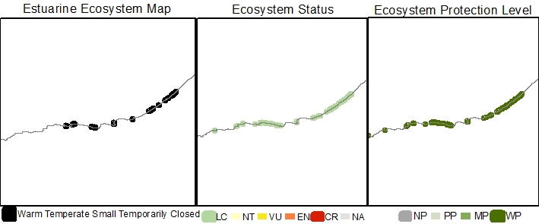
Estuarine Ecosystem type | Warm Temperate Small Temporarily Closed
Ecosystem ID | To be provided by SANBI
NBA 2018 Coastal Classification | Coastal Classification NCM NBA2018 - To be provided by SANBI
Ecosystem type version history | 2018☐ 2024☐
Biogeographical Region | Warm Temperate
Ecosystem Threat Status (IUCN RLE v1.1): | Least Concern
Assesment findings | Warm Temperate Small Temporarily Closed estuaries occurs in a remote part of the country and currently there are no substantial, known biotic disruptions or pressures, as such it is considered Least Concern.
Trigger criteria: | -
Other criteria considered: | C3 – Environmental degradation since 1750  A3 – historical and future reductions in geographic range  B3 – Restricted geographic range
Assessment Scope: | National
Assessment type: | Systematic assessment
Date assessed: | 2018/2019
Year published: | 2020
Provincial distribution: | Western Cape and Eastern Cape
Historical extent (km²): | 16.2
Remaining natural extent (%): | 28% Natural & 52 % Near natural.
Conservation Target | 3.2 km² - 20 % (new ecosystem type, not included in 2011 National Estuaries Biodiversity Plan)
Area protected | 22 %
Natural Area under very high & high fishing pressure | 0 %
Protection level from National Biodiversity Assessment 2018: | Well protected
Ecosystem description: | The sizable temporarily open/closed category of Whitfield (1992) was divided into Small and Large Temporarily Closed estuaries in 2019 using a total habitat area of 15ha (associated with ~10ha of open water area) as the dividing threshold. The division was based on differences in biophysical processes and patterns. Small temporarily closed systems are likely to experience rapid increases and decreases freshwater runoff over a few hours making them strongly event-driven. As a result of there small volume there are little scouring during breachings, and a semi-closed mouth condition can easily develop owing to a small, perched, outflow channel that restricts tidal amplitude to 10 to 15cm. There is also minimal water column area during the open state. Habitat diversity is low (no intertidal salt marshes) and species diversity and abundance reduced. Similarly fish assemblages are limited to a few species. Systems tend to be linear or funnel-shaped with highly restricted inlets. Smaller systems especially tend to be ‘perched’ above normal tidal levels, resulting in little to no open water area during the open mouth low tide state. Water levels are dominated by the state of the mouth, with highest levels of 1 m to 2 m above mean sea level during the closed phase. Tidal ranges are very restricted, ranging between 15-30 cm in Small Temporarily Closed estuaries. Open phase mixing processes are dominated by fluvial input and partially by tides. When closed, wind and seepage losses through the berm play a key role. Sediment composition is largely stable, resetting mainly during floods. Small Temporarily Closed estuaries tend to be fresher in character than Large Temporarily Closed as they have less connectivity with the sea.
Rain season: | All Year, Early to Very Late Summer
Altitude: | Between 0 masl and 5 masl.
Mean Annual Runoff: | 0.2 to 43.5 x10⁶ m³/annum
Temperature: | Average monthly maximum in summer is between 19 and 22 °C and Average monthly minimum in winter is between 13 and 17°C.
Endemic taxa
Economically important taxa
Ecologically important taxa
Endemic taxa
Primary threatening processes: | 23% of ecosystem extent under severe pollution pressure (very high to high levels) from Wastewater Treatment works, urban storm water and agricultural return flow.  21% of ecosystem extent under severe flow modification pressure.  10% of ecosystem extent is under severe land-use change (mostly urban development and agriculture) pressure  4% of ecosystem extent is under severe alien/extralimital fish pressure causing disruption of pattern and process in fresher and brackish zones.  4% of ecosystem extent is under severe alien invasive plant pressure in one or more of their reaches.  Little fishing pressure due to estuary size.
Limitations and knowledge gaps | While the condition assessments for most systems have been updated, the under-pinning survey data is between 20 and 30 years old. It is therefore of critical importance that more up to date nation-wide surveys be conducted to improve our overall confidence in the estimated change for the different ecosystem types and to inform future assessments.  Estuaries are interconnected over local, bioregional and global scales. Ecosystems threat status are just one of a range of measures that document the decline in condition and the response to an escalating human footprint. The results of the ecosystem threat status assessment should not be decoupled from the overall regional findings and the deeply concerning trend of large gaps in functioning estuaries due to collective poor condition along urban coastlines.
Estuaries in Ecosystem (estuary ID) | Klipdrifsfontein (35)  Blinde (40)  Tweekuilen (41)  Gericke (42)  Gwaing (47)  Noetsie (53)  Matjies (56)  Groot (Wes) (58)  Tsitsikamma (65)  Klipdrif (Oos) (66)  Slang (67)  Baakens (74)  Papkuils (75)  Boknes (79)  Grant's (82)  Rufane (85)  Riet (86)  Ngculura (Ngculurha) (96)  Mtana (97)  Nqinisa (99)  Shelbertsstroom (102)  Lilyvale (103)  Ross' Creek (104)  Mlele (106)  Mcantsi (107)  Hlozi (110)  Hickman's (111)  Blind (113)  Hlaze (iHlanze) (114)  Cunge (120)  Imtwendwe (Mtwendwe) (125)  Haga-haga (126)  Mtendwe (127)  Cwili (130)  Ngogwane (133)  Ncizele (135)  Timba (136)  Zalu (141)  Sihlontlweni (143)  Nebelele (144)  Jujura (Jujurha) (146)  Ngadla (147)  Beechamwood (149)  Kwazlelitsha (Kwazwedala) (150)  Kwa-Goqo (151)  Ku-Nocekedwa (152)  Ngomane (East) (154)  Ngoma/Kobule (155)
Assessors | Van Niekerk, L., Adams, J.B., Lamberth, S.J., Turpie, J., MacKay, F., Sink, K. & Skowno, A.L
Reviewers | National Biodiversity Assessment Estuaries Reference Group (2016-2019) (2018 version).
Data sources | Dayaram, A., Skowno, A.L., Driver, A., Sink, K., Van Deventer, H., Smith-Adao, L., Van Niekerk, L., Harris, L.R., Job, N. & Nel, J.L. 2021. The South African National Ecosystem Classification System Handbook: First Edition. South African National Biodiversity Institute, Pretoria, South Africa. http://hdl.handle.net/20.500.12143/7150  GeoTerraImage (2015) Technical Report: 1990 South African National Land Cover Dataset version 5.2. Pretoria, 63 pp. SANBI Threatened Species Unit pers com (2020) Threatened plant species database of South Africa.  Van Niekerk, L, Adams JB, James, N, Lamberth S, Mackay F, Rajkaran A, Turpie J, Weerts S, Whitfield AK. 2020. An Estuary Ecosystem Classification that encompasses biogeography and a high diversity of types in support of protection and management. African Journal of Aquatic Science, 45: 199-216.  Van Niekerk, L., Adams, J.B., Lamberth, S.J., Turpie, J., MacKay, F., Sink, K. & Skowno, A.L., 2019, ‘Chapter 8: Ecosystem Threat Status and Protection levels’ in South African National Biodiversity Assessment 2018: Technical Report. Volume 3: Estuarine Realm. CSIR report number CSIR/SPLA/EM/EXP/2019/0062/A. South African National Biodiversity Institute, Pretoria. Report Number: http://hdl.handle.net/20.500.12143/6373.
Author (s) of Factsheet | Van Niekerk, L., Adams, J.B., Lamberth, Dayaram, A.
Recommended Citation | South African National Biodiversity Institute (2022-). [Name], Online, webpage link (unknown), accessed on [download date]
Image | [Link to images of ecosystem if available].*

Subtropical Estuarine Bay
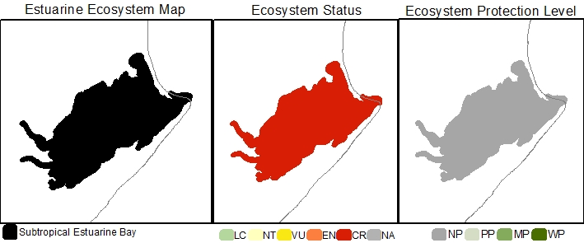
Estuarine Ecosystem type | Subtropical Estuarine Bay
Ecosystem ID | To be provided by SANBI
NBA 2018 Coastal Classification | Coastal Classification NCM NBA2018 - To be provided by SANBI
Ecosystem type version history | 2018☒ 2024☐
Biogeographical Region | Subtropical
Ecosystem Threat Status (IUCN RLE v1.1): | Critically Endangered
Assesment findings | The Subtropical Estuarine Bay are threatened by ongoing environmental degradation, specifically from land-use change (specifically port development), pollution, overexploitation of living resources and flow modification pressures.
Trigger criteria: | C3 – Environmental degradation since 1750
Other criteria considered: | A3 – historical and future reductions in geographic range  B3 – Restricted geographic range
Assessment Scope: | National
Assessment type: | Systematic assessment
Date assessed: | 2018/2019
Year published: | 2020
Provincial distribution: | KwaZulu-Natal
Historical extent (km²): | 28.2
Remaining natural extent (%): | 0%
Conservation Target | 5.6 km² - 20 %
Area protected | 0 %
Natural Area under very high & high fishing pressure | 0 %
Protection level from National Biodiversity Assessment 2018: | Not protected
Ecosystem description: | Estuarine Bays are permanently linked to the sea by unrestricted, deep mouths and are dominated by tidal processes, with tidal amplitudes close to those of the sea. Members of this ecosystem type are large systems (>1200 ha) with generally round basins where only the upper reaches experience a degree of constriction to tidal flows. As a result of relatively low river inputs they have a predominantly euhaline salinity regime in the lower and mid reaches, with freshwater mixing processes being mostly confined to the restricted upper areas. Sediments are typically marine in origin and grain size distributions are stable. There are only two natural occurrences of Estuarine Bays in South Africa (viz. Knysna (Warm Temperate) and Durban Bay (Subtropical).
Rain season: | Late Summer
Altitude: | Between 0 masl and 5 masl.
Mean Annual Runoff: | 36.3 x10⁶ m³/annum
Temperature: | Average monthly maximum in summer is 24 °C and Average monthly minimum in winter is 17°C.
Endemic taxa
Economically important taxa
Ecologically important taxa
Endemic taxa
Primary threatening processes: | 100% of ecosystem extent under land use change and develop pressure (very high to high levels) in particular from port development.  100% of ecosystem extent under severe pollution pressure (very high to high levels) from Wastewater Treatment works, urban storm water and agricultural return flow.  100% of ecosystem extent is also under severe fishing and flow modification pressure, respectively.
Limitations and knowledge gaps | While the condition assessments for most systems have been updated, the under-pinning survey data is between 20 and 30 years old. It is therefore of critical importance that more up to date nation-wide surveys be conducted to improve our overall confidence in the estimated change for the different ecosystem types and to inform future assessments.  Estuaries are interconnected over local, bioregional and global scales. Ecosystems threat status are just one of a range of measures that document the decline in condition and the response to an escalating human footprint. The results of the ecosystem threat status assessment should not be decoupled from the overall regional findings and the deeply concerning trend of large gaps in functioning estuaries due to collective poor condition along urban coastlines.
Estuaries in Ecosystem (estuary ID) | Durban Bay (268)
Assessors | Van Niekerk, L., Adams, J.B., Lamberth, S.J., Turpie, J., MacKay, F., Sink, K. & Skowno, A.L
Reviewers | National Biodiversity Assessment Estuaries Reference Group (2016-2019) (2018 version).
Data sources | Dayaram, A., Skowno, A.L., Driver, A., Sink, K., Van Deventer, H., Smith-Adao, L., Van Niekerk, L., Harris, L.R., Job, N. & Nel, J.L. 2021. The South African National Ecosystem Classification System Handbook: First Edition. South African National Biodiversity Institute, Pretoria, South Africa. http://hdl.handle.net/20.500.12143/7150  GeoTerraImage (2015) Technical Report: 1990 South African National Land Cover Dataset version 5.2. Pretoria, 63 pp. SANBI Threatened Species Unit pers com (2020) Threatened plant species database of South Africa.  Van Niekerk, L, Adams JB, James, N, Lamberth S, Mackay F, Rajkaran A, Turpie J, Weerts S, Whitfield AK. 2020. An Estuary Ecosystem Classification that encompasses biogeography and a high diversity of types in support of protection and management. African Journal of Aquatic Science, 45: 199-216.  Van Niekerk, L., Adams, J.B., Lamberth, S.J., Turpie, J., MacKay, F., Sink, K. & Skowno, A.L., 2019, ‘Chapter 8: Ecosystem Threat Status and Protection levels’ in South African National Biodiversity Assessment 2018: Technical Report. Volume 3: Estuarine Realm. CSIR report number CSIR/SPLA/EM/EXP/2019/0062/A. South African National Biodiversity Institute, Pretoria. Report Number: http://hdl.handle.net/20.500.12143/6373.
Author (s) of Factsheet | Van Niekerk, L., Adams, J.B., Lamberth, Dayaram, A.
Recommended Citation | South African National Biodiversity Institute (2022-). [Name], Online, webpage link (unknown), accessed on [download date]
Image | [Link to images of ecosystem if available].*

Subtropical Estuarine Lake

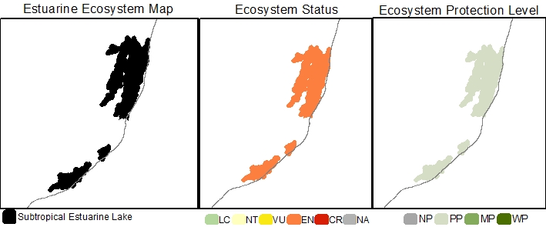
Estuarine Ecosystem type | Subtropical Estuarine Lake
Ecosystem ID | To be provided by SANBI
NBA 2018 Coastal Classification | Coastal Classification NCM NBA2018 - To be provided by SANBI
Ecosystem type version history | 2018☒ 2024☐
Biogeographical Region | Subtropical
Ecosystem Threat Status (IUCN RLE v1.1): | Endangered
Assesment findings | Subtropical Estuarine Lakes are threatened by ongoing environmental degradation, specifically from overexploitation of living resources, mouth manipulation, pollution, surface and groundwater abstraction, land-use change, and biological invasions pressures.
Trigger criteria: | C3 – Environmental degradation since 1750
Other criteria considered: | A3 – historical and future reductions in geographic range  B3 – Restricted geographic range
Assessment Scope: | National
Assessment type: | Systematic assessment
Date assessed: | 2018/2019
Year published: | 2020
Provincial distribution: | KwaZulu-Natal
Historical extent (km²): | 818.6
Remaining natural extent (%): | 0%
Conservation Target | 163.7 km² - 20 %
Area protected | 76 %
Natural Area under very high & high fishing pressure | 0 %
Protection level from National Biodiversity Assessment 2018: | Poorly protected
Ecosystem description: | Estuarine Lake ecosystems comprise one or more large circular water bodies connected to the sea by a constricted inlet channel (Whitfield 1992; Van Niekerk et al., 2020). Maximum water levels are determined by berm height, mouth state (open/close) and freshwater input. Marine connectivity varies from almost permanently open to closed on annual scales. Salinities are highly variable, ranging from fresh to hypersaline because of differing freshwater input (surface and groundwater), evaporation and the extent of the marine connection (. Mixing processes are dominated by wind and, to a lesser extent fluvial inputs, owing to their restricted mouths and relatively large surface areas. Average tidal amplitudes are negligible (15 – 20 cm) when connected to the sea, primarily due to restricted mouth conditions. Sediment processes tend to be stable, with infilling occurring over long time scales and resetting confined to larger flood events.
Rain season: | Mid/Late Summer
Altitude: | Between 0 masl and 5 masl.
Mean Annual Runoff: | 29 to 645 x10⁶ m³/annum
Temperature: | Average monthly maximum in summer is 25 °C and Average monthly minimum in winter is 18°C.
Endemic taxa
Economically important taxa
Ecologically important taxa
Endemic taxa
Primary threatening processes: | 100% of ecosystem extent under severe fishing pressure (very high to high levels).  100% of ecosystem extent is under severe mouth manipulation pressure.  75% of ecosystem extent under severe pollution pressure from Wastewater Treatment works, urban storm water and agricultural return flow.  75% of ecosystem extent is under severe land-use change (mostly urban development and agriculture) pressure.  25% of ecosystem extent is under severe flow modification pressure.  25% of ecosystem extent is under severe alien/extralimital fish pressure causing disruption of pattern and process in fresher and brackish zones.
Limitations and knowledge gaps | While the condition assessments for most systems have been updated, the under-pinning survey data is between 20 and 30 years old. It is therefore of critical importance that more up to date nation-wide surveys be conducted to improve our overall confidence in the estimated change for the different ecosystem types and to inform future assessments.  Estuaries are interconnected over local, bioregional and global scales. Ecosystems threat status are just one of a range of measures that document the decline in condition and the response to an escalating human footprint. The results of the ecosystem threat status assessment should not be decoupled from the overall regional findings and the deeply concerning trend of large gaps in functioning estuaries due to collective poor condition along urban coastlines.
Estuaries in Ecosystem (estuary ID) | uMhlathuze (284)  Richards Bay (285)  iNhlabane (286)  St Lucia (288)
Assessors | Van Niekerk, L., Adams, J.B., Lamberth, S.J., Turpie, J., MacKay, F., Sink, K. & Skowno, A.L
Reviewers | National Biodiversity Assessment Estuaries Reference Group (2016-2019) (2018 version).
Data sources | Dayaram, A., Skowno, A.L., Driver, A., Sink, K., Van Deventer, H., Smith-Adao, L., Van Niekerk, L., Harris, L.R., Job, N. & Nel, J.L. 2021. The South African National Ecosystem Classification System Handbook: First Edition. South African National Biodiversity Institute, Pretoria, South Africa. http://hdl.handle.net/20.500.12143/7150  GeoTerraImage (2015) Technical Report: 1990 South African National Land Cover Dataset version 5.2. Pretoria, 63 pp. SANBI Threatened Species Unit pers com (2020) Threatened plant species database of South Africa.  Van Niekerk, L, Adams JB, James, N, Lamberth S, Mackay F, Rajkaran A, Turpie J, Weerts S, Whitfield AK. 2020. An Estuary Ecosystem Classification that encompasses biogeography and a high diversity of types in support of protection and management. African Journal of Aquatic Science, 45: 199-216.  Van Niekerk, L., Adams, J.B., Lamberth, S.J., Turpie, J., MacKay, F., Sink, K. & Skowno, A.L., 2019, ‘Chapter 8: Ecosystem Threat Status and Protection levels’ in South African National Biodiversity Assessment 2018: Technical Report. Volume 3: Estuarine Realm. CSIR report number CSIR/SPLA/EM/EXP/2019/0062/A. South African National Biodiversity Institute, Pretoria. Report Number: http://hdl.handle.net/20.500.12143/6373.
Author (s) of Factsheet | Van Niekerk, L., Adams, J.B., Lamberth, Dayaram, A.
Recommended Citation | South African National Biodiversity Institute (2022-). [Name], Online, webpage link (unknown), accessed on [download date]
Image | [Link to images of ecosystem if available].*

Subtropical Large Fluvially Dominated

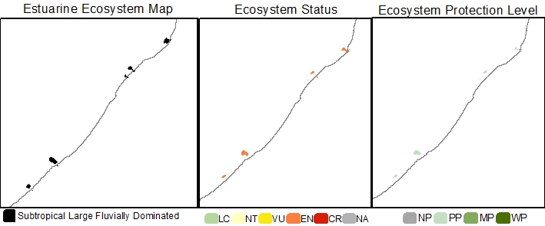
Estuarine Ecosystem type | Subtropical Large Fluvially Dominated
Ecosystem ID | To be provided by SANBI
NBA 2018 Coastal Classification | Coastal Classification NCM NBA2018 - To be provided by SANBI
Ecosystem type version history | 2018☒ 2024☐
Biogeographical Region | Subtropical
Ecosystem Threat Status (IUCN RLE v1.1): | Endangered
Assesment findings | The Subtropical Large Fluvially Dominated estuaries are threatened by ongoing environmental degradation, specifically from over-exploitation of living resources (Illegal gill netting), pollution, biological invasions, land-use change, and water abstraction. These systems are also experiencing historical reductions in geographic range. Due to ongoing urbanisation this trend is likely to continue.
Trigger criteria: | C3 – Environmental degradation since 1750  A3 – historical and future reductions in geographic range
Other criteria considered: | B3 – Restricted geographic range
Assessment Scope: | National
Assessment type: | Systematic assessment
Date assessed: | 2018/2019
Year published: | 2020
Provincial distribution: | Eastern Cape and KwaZulu-Natal
Historical extent (km²): | 107.7
Remaining natural extent (%): | 12% Near Natural
Conservation Target | 21.5 km² - 20 % (new ecosystem type, not included in 2011 National Estuaries Biodiversity Plan)
Area protected | 46 %
Natural Area under very high & high fishing pressure | 19 %
Protection level from National Biodiversity Assessment 2018: | Poorly protected
Ecosystem description: | Large Fluvially Dominated estuaries are large, shallow, sediment-rich, freshwater dominated systems with a very high sediment turnover, often develop ebb-tidal deltas, are turbid and can close during periods of low flow, e.g. uThukela and Orange estuaries. Estuary mouths tend to be constricted and can even periodically close during low flows. River processes are dominant, and salinities are mostly fresh throughout the estuary for more than half the time. During peak flood conditions, outflows can influence salinities for considerable distances offshore. Fluvially Dominated systems was previous characterised as river mouths by Whitfield (1992).
Rain season: | Mid/Late Summer
Mean Annual Runoff: | 374.7 to 3 753.6 x10⁶ m³/annum
Altitude: | Between 0 masl and 5 masl.
Temperature: | Average monthly maximum in summer is between 22 and 25 °C and Average monthly minimum in winter is between 17 and 18°C.
Endemic taxa
Economically important taxa
Ecologically important taxa
Endemic taxa
Primary threatening processes: | 80% of ecosystem extent under severe fishing pressure (very high to high levels), especially illegal gillnetting (poaching).  80% of ecosystem extent under severe pollution pressure from wastewater treatment works, urban storm water and agricultural return flow.  80% of ecosystem extent is under severe alien/extralimital fish pressure causing disruption of pattern and process in fresher and brackish zones.  60% of ecosystem extent is under severe land-use change (mostly urban development and agriculture) pressure.  40% of ecosystem extent is under severe alien invasive plant pressure in one or more of their reaches.  20% of ecosystem extent is under severe flow modification pressure.
Limitations and knowledge gaps | While the condition assessments for most systems have been updated, the under-pinning survey data is between 20 and 30 years old. It is therefore of critical importance that more up to date nation-wide surveys be conducted to improve our overall confidence in the estimated change for the different ecosystem types and to inform future assessments.  Estuaries are interconnected over local, bioregional and global scales. Ecosystems threat status are just one of a range of measures that document the decline in condition and the response to an escalating human footprint. The results of the ecosystem threat status assessment should not be decoupled from the overall regional findings and the deeply concerning trend of large gaps in functioning estuaries due to collective poor condition along urban coastlines.
Estuaries in Ecosystem (estuary ID) | Mbashe (158)  Mzimvubu (190)  uMvoti (276)  uThukela (280)  iMfolozi/uMsunduze (287)
Assessors | Van Niekerk, L., Adams, J.B., Lamberth, S.J., Turpie, J., MacKay, F., Sink, K. & Skowno, A.L
Reviewers | National Biodiversity Assessment Estuaries Reference Group (2016-2019) (2018 version).
Data sources | Dayaram, A., Skowno, A.L., Driver, A., Sink, K., Van Deventer, H., Smith-Adao, L., Van Niekerk, L., Harris, L.R., Job, N. & Nel, J.L. 2021. The South African National Ecosystem Classification System Handbook: First Edition. South African National Biodiversity Institute, Pretoria, South Africa. http://hdl.handle.net/20.500.12143/7150  GeoTerraImage (2015) Technical Report: 1990 South African National Land Cover Dataset version 5.2. Pretoria, 63 pp. SANBI Threatened Species Unit pers com (2020) Threatened plant species database of South Africa.  Van Niekerk, L, Adams JB, James, N, Lamberth S, Mackay F, Rajkaran A, Turpie J, Weerts S, Whitfield AK. 2020. An Estuary Ecosystem Classification that encompasses biogeography and a high diversity of types in support of protection and management. African Journal of Aquatic Science, 45: 199-216.  Van Niekerk, L., Adams, J.B., Lamberth, S.J., Turpie, J., MacKay, F., Sink, K. & Skowno, A.L., 2019, ‘Chapter 8: Ecosystem Threat Status and Protection levels’ in South African National Biodiversity Assessment 2018: Technical Report. Volume 3: Estuarine Realm. CSIR report number CSIR/SPLA/EM/EXP/2019/0062/A. South African National Biodiversity Institute, Pretoria. Report Number: http://hdl.handle.net/20.500.12143/6373.
Author (s) of Factsheet | Van Niekerk, L., Adams, J.B., Lamberth, Dayaram, A.
Recommended Citation | South African National Biodiversity Institute (2022-). [Name], Online, webpage link (unknown), accessed on [download date]
Image | [Link to images of ecosystem if available].*

Subtropical Predominantly Open

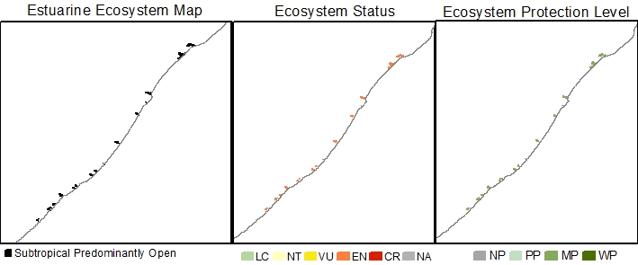
Estuarine Ecosystem type | Subtropical Predominantly Open
Ecosystem ID | To be provided by SANBI
NBA 2018 Coastal Classification | Coastal Classification NCM NBA2018 - To be provided by SANBI
Ecosystem type version history | 2018☒ 2024☐
Biogeographical Region | Subtropical
Ecosystem Threat Status (IUCN RLE v1.1): | Endangered
Assesment findings | Subtropical Predominantly Open estuaries are experiencing historical reductions in geographic range. Due to ongoing urbanisation this trend is likely to continue. These systems are also threatened by ongoing environmental degradation, specifically from over-exploitation of living resources, pollution, land-use change, flow reduction, and biological invasions pressures.
Trigger criteria: | A3 – historical and future reductions in geographic range
Other criteria considered: | C3 – Environmental degradation since 1750  B3 – Restricted geographic range
Assessment Scope: | National
Assessment type: | Systematic assessment
Date assessed: | 2018/2019
Year published: | 2020
Provincial distribution: | Eastern Cape and KwaZulu-Natal
Historical extent (km²): | 76.9
Remaining natural extent (%): | 3% Natural & 71% Near Natural
Conservation Target | 15.4 km² - 20 %
Area protected | 19 %
Natural Area under very high & high fishing pressure | 94 %
Protection level from National Biodiversity Assessment 2018: | Moderately protected
Ecosystem description: | Estuaries in this ecosystem type are open to the sea for more than 90% of the time (Whitfield 1992; Van Niekerk et al. 2019; 2020). Some are permanently open owing to perennial river flows or the presence of large tidal prisms. Tidal amplitude ranges from 0.75-1.5 m. Predominantly Open estuaries are linear systems in which mixing processes are dominated by both fluvial inputs and tidal action creating vertical and horizontal salinity gradients. Under low flows, hypersalinity can develop in the upper reaches of the temperate systems.  The degree to which the mouth is restricted depends on the rate and volume of freshwater inflow. Some systems become severely constricted during low flow periods, decreasing the tidal amplitude and increasing the duration of the ebb-tidal cycle. Regular flooding results in relatively mobile sediments. Surprisingly, their size varies considerably, with smaller systems afforded a degree of protection against direct wave action by rocky headlands or subtidal reefs, which assists in maintaining an open mouth.
Rain season: | Early to Late Summer
Altitude: | Between 0 masl and 5 masl.
Mean Annual Runoff: | 36.6 to 1 452.5 x10⁶ m³/annum
Temperature: | Average monthly maximum in summer is between 22 and 25 °C and Average monthly minimum in winter is between 17 and 18°C.
Endemic taxa
Economically important taxa
Ecologically important taxa
Endemic taxa
Primary threatening processes: | 94% of ecosystem extent under severe fishing pressure (very high to high levels), mostly illegal gillnetting (poaching).  19% of ecosystem extent under severe pollution pressure from Wastewater Treatment works, urban storm water and agricultural return flow.  19% of ecosystem extent is under severe land-use change (mostly urban development and agriculture) pressure.  13% of ecosystem extent is under severe flow modification pressure.  6% of ecosystem extent is under severe mouth manipulation pressure.  32% of ecosystem extent is under severe alien/extralimital fish pressure causing disruption of pattern and process in fresher and brackish zones.  6% of ecosystem extent is under severe alien invasive plant pressure in one or more of their reaches.
Limitations and knowledge gaps | While the condition assessments for most systems have been updated, the under-pinning survey data is between 20 and 30 years old. It is therefore of critical importance that more up to date nation-wide surveys be conducted to improve our overall confidence in the estimated change for the different ecosystem types and to inform future assessments.  Estuaries are interconnected over local, bioregional and global scales. Ecosystems threat status are just one of a range of measures that document the decline in condition and the response to an escalating human footprint. The results of the ecosystem threat status assessment should not be decoupled from the overall regional findings and the deeply concerning trend of large gaps in functioning estuaries due to collective poor condition along urban coastlines.
Estuaries in Ecosystem (estuary ID) | Xora (165)  Mtata (174)  Mdumbi (176)  Mtakatye (179)  Mngazana (185)  Mntafufu (193)  Mzintlava (195)  Msikaba (203)  Mtentu (206)  Mzamba (213)  uMzimkhulu (234)  uMkhomazi (259)  iSiphingo (267)  uMngeni (269)  aMatigulu/iNyoni (281)  uMlalazi (283)
Assessors | Van Niekerk, L., Adams, J.B., Lamberth, S.J., Turpie, J., MacKay, F., Sink, K. & Skowno, A.L
Reviewers | National Biodiversity Assessment Estuaries Reference Group (2016-2019) (2018 version).
Data sources | Dayaram, A., Skowno, A.L., Driver, A., Sink, K., Van Deventer, H., Smith-Adao, L., Van Niekerk, L., Harris, L.R., Job, N. & Nel, J.L. 2021. The South African National Ecosystem Classification System Handbook: First Edition. South African National Biodiversity Institute, Pretoria, South Africa. http://hdl.handle.net/20.500.12143/7150  GeoTerraImage (2015) Technical Report: 1990 South African National Land Cover Dataset version 5.2. Pretoria, 63 pp. SANBI Threatened Species Unit pers com (2020) Threatened plant species database of South Africa.  Van Niekerk, L, Adams JB, James, N, Lamberth S, Mackay F, Rajkaran A, Turpie J, Weerts S, Whitfield AK. 2020. An Estuary Ecosystem Classification that encompasses biogeography and a high diversity of types in support of protection and management. African Journal of Aquatic Science, 45: 199-216.  Van Niekerk, L., Adams, J.B., Lamberth, S.J., Turpie, J., MacKay, F., Sink, K. & Skowno, A.L., 2019, ‘Chapter 8: Ecosystem Threat Status and Protection levels’ in South African National Biodiversity Assessment 2018: Technical Report. Volume 3: Estuarine Realm. CSIR report number CSIR/SPLA/EM/EXP/2019/0062/A. South African National Biodiversity Institute, Pretoria. Report Number: http://hdl.handle.net/20.500.12143/6373.
Author (s) of Factsheet | Van Niekerk, L., Adams, J.B., Lamberth, Dayaram, A.
Recommended Citation | South African National Biodiversity Institute (2022-). [Name], Online, webpage link (unknown), accessed on [download date]
Image | [Link to images of ecosystem if available].*

Subtropical Large Temporarily Closed

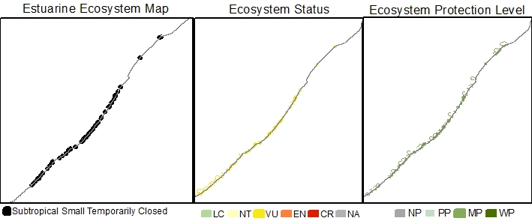
Estuarine Ecosystem type | Subtropical Large Temporarily Closed
Ecosystem ID | To be provided by SANBI
NBA 2018 Coastal Classification | Coastal Classification NCM NBA2018 - To be provided by SANBI
Ecosystem type version history | 2018☒ 2024☐
Biogeographical Region | Subtropical
Ecosystem Threat Status (IUCN RLE v1.1): | Endangered
Assesment findings | Subtropical Large Temporarily Closed estuaries are experiencing historical reductions in geographic range. Due to ongoing urbanisation this trend is likely to continue. These systems are also threatened by ongoing environmental degradation, specifically from land-use change, pollution, over-exploitation of living resources, flow reduction, mouth manipulation and biological invasions pressures.
Trigger criteria: | A3 – historical and future reductions in geographic range
Other criteria considered: | C3 – Environmental degradation since 1750  B3 – Restricted geographic range
Assessment Scope: | National
Assessment type: | Systematic assessment
Date assessed: | 2018/2019
Year published: | 2020
Provincial distribution: | Eastern Cape and KwaZulu-Natal
Historical extent (km²): | 52.1
Remaining natural extent (%): | 12% Natural and 34% Near Natural
Conservation Target | 10.4 km² - 20 % (new ecosystem type, not included in 2011 National Estuaries Biodiversity Plan)
Area protected | 7 %
Natural Area under very high & high fishing pressure | 6 %
Protection level from National Biodiversity Assessment 2018: | Poorly protected
Ecosystem description: | The extensive temporarily open/closed category of Whitfield (1992) was divided into Large and Small Temporarily Closed estuaries in 2019 using a total habitat area of 15ha (associated with ~10ha of open water area) as the dividing threshold. The division was based on differences in biophysical processes and patterns. Large temporarily closed systems are likely to experience increases and decreases freshwater runoff over hours to days making them highly responsive to changes in runoff. Systems tend to be linear or funnel-shaped with highly restricted inlets. Systems along exposed coastlines especially tend to be ‘perched’ above normal tidal levels, resulting in limited open water area during the open mouth low tide state. Water levels are dominated by the state of the mouth, with highest levels of 1 m to 2 m above mean sea level during the closed phase. Tidal ranges are very restricted, ranging between 25-50 cm. During the open phase mixing processes are dominated by fluvial input and partially by tides. When closed, wind and seepage losses through the berm play a key role. Sediment composition is largely stable, resetting mainly during floods and partially during breaching of the mouth. Salinity regimes range from almost fresh to hypersaline, which can develop during times of low flow or droughts.
Rain season: | Early to Very Late Summer
Altitude: | Between 0 masl and 5 masl.
Mean Annual Runoff: | 0.7 to 275.2 x10⁶ m³/annum
Temperature: | Average monthly maximum in summer is between 22 and 24 °C and Average monthly minimum in winter is between 16 and 18°C.
Endemic taxa
Economically important taxa
Ecologically important taxa
Endemic taxa
Primary threatening processes: | 47% of ecosystem extent is under severe (very high to high) land-use change pressure, mostly from urban development and agriculture.  42% of ecosystem extent under severe pollution pressure from wastewater treatment works, urban storm water and agricultural return flow.  13% of ecosystem extent under severe fishing pressure (mostly illegal gillnetting (poaching)).  13% of ecosystem extent is under severe flow modification pressure.  4% of ecosystem extent is under severe mouth manipulation pressure.  9% of ecosystem extent is under severe alien/extralimital fish pressure causing disruption of pattern and process in fresher and brackish zones.  4% of ecosystem extent is under severe alien invasive plant pressure in one or more of their reaches.
Limitations and knowledge gaps | While the condition assessments for most systems have been updated, the under-pinning survey data is between 20 and 30 years old. It is therefore of critical importance that more up to date nation-wide surveys be conducted to improve our overall confidence in the estimated change for the different ecosystem types and to inform future assessments.  Estuaries are interconnected over local, bioregional and global scales. Ecosystems threat status are just one of a range of measures that document the decline in condition and the response to an escalating human footprint. The results of the ecosystem threat status assessment should not be decoupled from the overall regional findings and the deeply concerning trend of large gaps in functioning estuaries due to collective poor condition along urban coastlines.
Estuaries in Ecosystem (estuary ID) | Kwa-Suku (161)  Ntlonyane (162)  Nkanya (163)  Bulungula (166)  Mncwasa (170)  Mapuzi (173)  Lwandile (178)  Mnenu (181)  Mtonga (182)  Mpande (183)  Mngazi (186)  Nkodusweni (192)  Mnyameni (210)  uMthavuna (215)  iMpenjani (221)  uMhlangomkhulu (South) (Umhlangankulu) (222)  iMbizana (224)  oHlangeni (230)  iZotsha (231)  uMthente (235)  uMhlangomkhulu (North) (Mhlangamkulu) (236)  iDombe (237)  iKhoshwana (238)  uMzumbe (240)  uMhlabashana (241)  uMhlungwa (242)  uMfazezala (243)  uMthwalume (246)  uMvuzi (247)  iFafa (248)  iSezela (250)  uMuziwezinto (253)  uMahlongwane (258)  uMgababa (261)  uMsimbazi (262)  iLovu (263)  aManzimtoti (265)  iZimbokodo (266)  uMhlanga (270)  uMdloti (271)  uThongathi (272)  uMhlali (273)  uMdlotane (277)  iNonoti (278)  iZinkwazi (279)
Assessors | Van Niekerk, L., Adams, J.B., Lamberth, S.J., Turpie, J., MacKay, F., Sink, K. & Skowno, A.L
Reviewers | National Biodiversity Assessment Estuaries Reference Group (2016-2019) (2018 version).
Data sources | Dayaram, A., Skowno, A.L., Driver, A., Sink, K., Van Deventer, H., Smith-Adao, L., Van Niekerk, L., Harris, L.R., Job, N. & Nel, J.L. 2021. The South African National Ecosystem Classification System Handbook: First Edition. South African National Biodiversity Institute, Pretoria, South Africa. http://hdl.handle.net/20.500.12143/7150  GeoTerraImage (2015) Technical Report: 1990 South African National Land Cover Dataset version 5.2. Pretoria, 63 pp. SANBI Threatened Species Unit pers com (2020) Threatened plant species database of South Africa.  Van Niekerk, L, Adams JB, James, N, Lamberth S, Mackay F, Rajkaran A, Turpie J, Weerts S, Whitfield AK. 2020. An Estuary Ecosystem Classification that encompasses biogeography and a high diversity of types in support of protection and management. African Journal of Aquatic Science, 45: 199-216.  Van Niekerk, L., Adams, J.B., Lamberth, S.J., Turpie, J., MacKay, F., Sink, K. & Skowno, A.L., 2019, ‘Chapter 8: Ecosystem Threat Status and Protection levels’ in South African National Biodiversity Assessment 2018: Technical Report. Volume 3: Estuarine Realm. CSIR report number CSIR/SPLA/EM/EXP/2019/0062/A. South African National Biodiversity Institute, Pretoria. Report Number: http://hdl.handle.net/20.500.12143/6373.
Author (s) of Factsheet | Van Niekerk, L., Adams, J.B., Lamberth, Dayaram, A.
Recommended Citation | South African National Biodiversity Institute (2022-). [Name], Online, webpage link (unknown), accessed on [download date]
Image | [Link to images of ecosystem if available].*

Subtropical Small Temporarily Closed

Estuarine Ecosystem type | Subtropical Small Temporarily Closed
Ecosystem ID | To be provided by SANBI
NBA 2018 Coastal Classification | Coastal Classification NCM NBA2018 - To be provided by SANBI
Ecosystem type version history | 2018☒ 2024☐
Biogeographical Region | Subtropical
Ecosystem Threat Status (IUCN RLE v1.1): | Vulnerable
Assesment findings | Subtropical Small Temporarily Closed estuaries are experiencing historical reductions in geographic range. Due to ongoing urbanisation this trend is likely to continue. These systems are also threatened by ongoing environmental degradation, specifically from pollution, land-use change, flow reduction, and mouth manipulation.
Trigger criteria: | A3 – historical and future reductions in geographic range
Other criteria considered: | C3 – Environmental degradation since 1750  B3 – Restricted geographic range
Assessment Scope: | National
Assessment type: | Systematic assessment
Date assessed: | 2018/2019
Year published: | 2020
Provincial distribution: | Eastern Cape and KwaZulu-Natal
Historical extent (km²): | 20.5
Remaining natural extent (%): | 30% Natural & 31% Near Natural
Conservation Target | 4.1 km² - 20 % (new ecosystem type, not included in 2011 National Estuaries Biodiversity Plan)
Area protected | 25 %
Natural Area under very high & high fishing pressure | 7 %
Protection level from National Biodiversity Assessment 2018: | Moderately protected
Ecosystem description: | The sizable temporarily open/closed category of Whitfield (1992) was divided into Small and Large Temporarily Closed estuaries in 2019 using a total habitat area of 15ha (associated with ~10ha of open water area) as the dividing threshold. The division was based on differences in biophysical processes and patterns. Small temporarily closed systems are likely to experience rapid increases and decreases freshwater runoff over a few hours making them strongly event-driven. As a result of there small volume there are little scouring during breachings, and a semi-closed mouth condition can easily develop owing to a small, perched, outflow channel that restricts tidal amplitude to 10 to 15cm. There is also minimal water column area during the open state. Habitat diversity is low (no intertidal salt marshes) and species diversity and abundance reduced. Similarly fish assemblages are limited to a few species. Systems tend to be linear or funnel-shaped with highly restricted inlets. Smaller systems especially tend to be ‘perched’ above normal tidal levels, resulting in little to no open water area during the open mouth low tide state. Water levels are dominated by the state of the mouth, with highest levels of 1 m to 2 m above mean sea level during the closed phase. Tidal ranges are very restricted, ranging between 15-30 cm in Small Temporarily Closed estuaries. Open phase mixing processes are dominated by fluvial input and partially by tides. When closed, wind and seepage losses through the berm play a key role. Sediment composition is largely stable, resetting mainly during floods. Small Temporarily Closed estuaries tend to be fresher in character than Large Temporarily Closed as they have less connectivity with the sea.
Rain season: | Early to Very Late Summer
Altitude: | Between 0 masl and 5 masl.
Mean Annual Runoff: | 0.2 to 60.1 x10⁶ m³/annum
Temperature: | Average monthly maximum in summer is between 22 and 25 °C and Average monthly minimum in winter is between 16 and 18°C.
Endemic taxa
Economically important taxa
Ecologically important taxa
Endemic taxa
Primary threatening processes: | 37% of ecosystem extent under severe (very high to high) pollution pressure from wastewater treatment works, urban storm water and agricultural return flow.  22% of ecosystem extent is under severe land-use change pressure, mostly from urban development and agriculture.  11% of ecosystem extent is under severe flow modification pressure.  3% of ecosystem extent under severe fishing pressure (mostly illegal gillnetting (poaching)).  2% of ecosystem extent is under severe mouth manipulation pressure.  3% of ecosystem extent is under severe alien/extralimital fish pressure causing disruption of pattern and process in fresher and brackish zones.  2% of ecosystem extent is under severe alien invasive plant pressure in one or more of their reaches.
Limitations and knowledge gaps | While the condition assessments for most systems have been updated, the under-pinning survey data is between 20 and 30 years old. It is therefore of critical importance that more up to date nation-wide surveys be conducted to improve our overall confidence in the estimated change for the different ecosystem types and to inform future assessments.  Estuaries are interconnected over local, bioregional and global scales. Ecosystems threat status are just one of a range of measures that document the decline in condition and the response to an escalating human footprint. The results of the ecosystem threat status assessment should not be decoupled from the overall regional findings and the deeply concerning trend of large gaps in functioning estuaries due to collective poor condition along urban coastlines.
Estuaries in Ecosystem (estuary ID) | Kwanyambalala (0)  Ku-Mpenzu (159)  Ku-Bhula (Mbhanyana) (160)  Sundwana (164)  Ku-Amanzimuzama (167)  Nqakanqa (168)  Mdikana (169)  Mpako (171)  Nenga (172)  Thsani (175)  Lwandilana (177)  Hluleka (180)  Sinangwana (184)  Gxwaleni (187)  Bulolo (188)  Mtumbane (189)  Ntlupeni (191)  Ingo (194)  Mzimpunzi (196)  Mbotyi (198)  Mkozi (199)  Sikatsha (200)  Lupatana (201)  Mkweni (202)  Mgwegwe (204)  Mgwetyana (205)  Sikombe (207)  Kwanyana (208)  Mtolane (209)  Mpahlanyana (211)  Mpahlane (212)  Mtentwana (214)  iSolwane (216)  iSandlu (217)  uMbhoyibhoyi (218)  uMuntongazi (219)  iKhandalendlovu (220)  iKhaba (223)  iMvutshini (225)  iBilanhlonhlo (226)  uVuzana (227)  iKongeni (228)  uVunguza (229)  iBhobhoyi (232)  uMbango (233)  iNjambili (239)  uMakhosi (244)  uMnamfu (245)  uMdesingane (249)  uMkhumbane (251)  iNkomba (252)  uMzimayi (254)  Rocky Bay (255)  uMphambanyoni (256)  aMahlongwa (257)  iNgane (260)  aManzanamtoti (264)  BobΓÇÖs Stream (274)  uSetheni (275)  iSiyaya (282)
Assessors | Van Niekerk, L., Adams, J.B., Lamberth, S.J., Turpie, J., MacKay, F., Sink, K. & Skowno, A.L
Reviewers | National Biodiversity Assessment Estuaries Reference Group (2016-2019) (2018 version).
Data sources | Dayaram, A., Skowno, A.L., Driver, A., Sink, K., Van Deventer, H., Smith-Adao, L., Van Niekerk, L., Harris, L.R., Job, N. & Nel, J.L. 2021. The South African National Ecosystem Classification System Handbook: First Edition. South African National Biodiversity Institute, Pretoria, South Africa. http://hdl.handle.net/20.500.12143/7150  GeoTerraImage (2015) Technical Report: 1990 South African National Land Cover Dataset version 5.2. Pretoria, 63 pp. SANBI Threatened Species Unit pers com (2020) Threatened plant species database of South Africa.  Van Niekerk, L, Adams JB, James, N, Lamberth S, Mackay F, Rajkaran A, Turpie J, Weerts S, Whitfield AK. 2020. An Estuary Ecosystem Classification that encompasses biogeography and a high diversity of types in support of protection and management. African Journal of Aquatic Science, 45: 199-216.  Van Niekerk, L., Adams, J.B., Lamberth, S.J., Turpie, J., MacKay, F., Sink, K. & Skowno, A.L., 2019, ‘Chapter 8: Ecosystem Threat Status and Protection levels’ in South African National Biodiversity Assessment 2018: Technical Report. Volume 3: Estuarine Realm. CSIR report number CSIR/SPLA/EM/EXP/2019/0062/A. South African National Biodiversity Institute, Pretoria. Report Number: http://hdl.handle.net/20.500.12143/6373.
Author (s) of Factsheet | Van Niekerk, L., Adams, J.B., Lamberth, Dayaram, A.
Recommended Citation | South African National Biodiversity Institute (2022-). [Name], Online, webpage link (unknown), accessed on [download date]
Image | [Link to images of ecosystem if available].*

Tropical Estuarine Lake

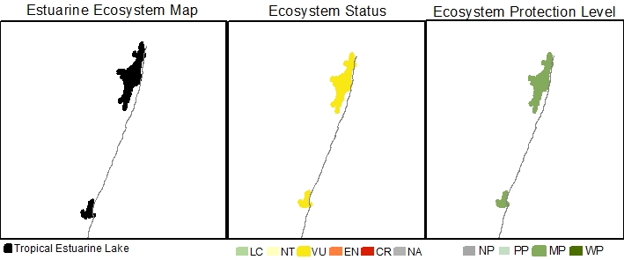
Estuarine Ecosystem type | Tropical Estuarine Lake
Ecosystem ID | To be provided by SANBI
NBA 2018 Coastal Classification | Coastal Classification NCM NBA2018 - To be provided by SANBI
Ecosystem type version history | 2018☒ 2024☐
Biogeographical Region | Tropical
Ecosystem Threat Status (IUCN RLE v1.1): | Vulnerable
Assesment findings | Tropical Estuarine Lakes are threatened by ongoing environmental degradation, specifically from overexploitation of living resources, land-use change and groundwater abstraction (forestry) pressure.
Trigger criteria: | B3 – Restricted geographic range
Other criteria considered: | A3 – historical and future reductions in geographic range  C3 – Environmental degradation since 1750
Assessment Scope: | National
Assessment type: | Systematic assessment
Date assessed: | 2018/2019
Year published: | 2020
Provincial distribution: | KwaZulu-Natal
Historical extent (km²): | 81.7
Remaining natural extent (%): | 90% Natural and 10% Near Natural
Conservation Target | 16.3km² - 20 % (new ecosystem type, not included in 2011 National Estuaries Biodiversity Plan)
Area protected | 92%
Area under very high & high fishing pressure | 100 % triggering downgrade to Moderately protected
Protection level from National Biodiversity Assessment 2018: | Moderately protected
Ecosystem description: | Estuarine Lake ecosystems comprise one or more large circular water bodies connected to the sea by a constricted inlet channel (Whitfield 1992; Van Niekerk et al., 2020). Maximum water levels are determined by berm height, mouth state (open/close) and freshwater input. Marine connectivity varies from almost permanently open to closed on annual scales. Salinities are highly variable, ranging from fresh to hypersaline because of differing freshwater input (surface and groundwater), evaporation and the extent of the marine connection (. Mixing processes are dominated by wind and, to a lesser extent fluvial inputs, owing to their restricted mouths and relatively large surface areas. Average tidal amplitudes are negligible (15 – 20 cm) when connected to the sea, primarily due to restricted mouth conditions. Sediment processes tend to be stable, with infilling occurring over long time scales and resetting confined to larger flood events.
Rain season: | Late Summer
Altitude: | Between 0 masl and 5 masl.
Mean Annual Runoff: | Ground water fed.
Temperature: | Average monthly maximum in summer is between 25 and 26 °C and Average monthly minimum in winter is 19°C.
Endemic taxa
Economically important taxa | The Kosi Tropical Estuarine Lakes supports the only artisanal fish traps fishery in South Africa.
Ecologically important taxa | Tropical Estuarine Lakes support extensive mangrove areas in South Africa.
Endemic taxa
Primary threatening processes: | 100% of ecosystem extent under very high to high fishing pressure (mostly traditions fish traps (Kosi) and illegal gillnetting (poaching) at uMgobezeleni).
Limitations and knowledge gaps | While the condition assessments for most systems have been updated, the under-pinning survey data is between 20 and 30 years old. It is therefore of critical importance that more up to date nation-wide surveys be conducted to improve our overall confidence in the estimated change for the different ecosystem types and to inform future assessments.  Estuaries are interconnected over local, bioregional and global scales. Ecosystems threat status are just one of a range of measures that document the decline in condition and the response to an escalating human footprint. The results of the ecosystem threat status assessment should not be decoupled from the overall regional findings and the deeply concerning trend of large gaps in functioning estuaries due to collective poor condition along urban coastlines.
Estuaries in Ecosystem (estuary ID) | uMgobezeleni (289)  Kosi (290)
Assessors | Van Niekerk, L., Adams, J.B., Lamberth, S.J., Turpie, J., MacKay, F., Sink, K. & Skowno, A.L
Reviewers | National Biodiversity Assessment Estuaries Reference Group (2016-2019) (2018 version).
Data sources | Dayaram, A., Skowno, A.L., Driver, A., Sink, K., Van Deventer, H., Smith-Adao, L., Van Niekerk, L., Harris, L.R., Job, N. & Nel, J.L. 2021. The South African National Ecosystem Classification System Handbook: First Edition. South African National Biodiversity Institute, Pretoria, South Africa. http://hdl.handle.net/20.500.12143/7150  GeoTerraImage (2015) Technical Report: 1990 South African National Land Cover Dataset version 5.2. Pretoria, 63 pp. SANBI Threatened Species Unit pers com (2020) Threatened plant species database of South Africa.  Van Niekerk, L, Adams JB, James, N, Lamberth S, Mackay F, Rajkaran A, Turpie J, Weerts S, Whitfield AK. 2020. An Estuary Ecosystem Classification that encompasses biogeography and a high diversity of types in support of protection and management. African Journal of Aquatic Science, 45: 199-216.  Van Niekerk, L., Adams, J.B., Lamberth, S.J., Turpie, J., MacKay, F., Sink, K. & Skowno, A.L., 2019, ‘Chapter 8: Ecosystem Threat Status and Protection levels’ in South African National Biodiversity Assessment 2018: Technical Report. Volume 3: Estuarine Realm. CSIR report number CSIR/SPLA/EM/EXP/2019/0062/A. South African National Biodiversity Institute, Pretoria. Report Number: http://hdl.handle.net/20.500.12143/6373.
Author (s) of Factsheet | Van Niekerk, L., Adams, J.B., Lamberth, Dayaram, A.
Recommended Citation | South African National Biodiversity Institute (2022-). [Name], Online, webpage link (unknown), accessed on [download date]
Image | [Link to images of ecosystem if available].*

Micro-estuaries (Not Assessed)

24.1 Cool Temperate Micro-estuary
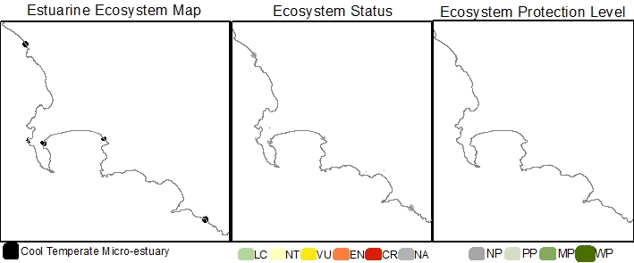
Estuarine Ecosystem type | Cool Temperate Micro-estuary
Ecosystem ID | To be provided by SANBI
NBA 2018 Coastal Classification | Coastal Classification NCM NBA2018 - To be provided by SANBI
Ecosystem type version history | 2018☒ 2024☐
Biogeographical Region | Cool Temperate
Ecosystem Threat Status (IUCN RLE v1.1): | Not Assessed
Assesment findings
Trigger criteria: | C3 – Environmental degradation since 1750
Other criteria considered: | A3 – historical and future reductions in geographic range  B3 – Restricted geographic range
Assessment Scope: | National
Assessment type: | Systematic assessment
Date assessed: | 2018/2019
Year published: | 2020
Provincial distribution: | Northern Cape and Western Cape
Historical extent (km²):
Remaining natural extent (%):
Conservation Target
Area protected
Area under very high & high fishing pressure
Protection level from National Biodiversity Assessment 2018: | Not Assessed
Ecosystem description: | Micro-estuaries are defined as small, permanent coastal water bodies (>1ha in area or >50m in length) in which mixing of salt and freshwater can periodically occur owing to overwash from the sea or breaching of the mouth. These small systems are likely to support low densities of a limited number of estuarine and marine species.
Rain season: | Winter
Altitude: | Between 0 masl and 5 masl.
Mean Annual Precipitation:
Temperature:
Endemic taxa
Economically important taxa
Ecologically important taxa
Endemic taxa
Primary threatening processes:
Limitations and knowledge gaps | Very little data available for a systematic assessment
Estuaries in Ecosystem (estuary ID) | Bokramspruit (0)  Cool Temperate 5  Elsies  Haelkraal  Modder
Assessors | Van Niekerk, L., Adams, J.B., Lamberth, S.J., Turpie, J., MacKay, F., Sink, K. & Skowno, A.L
Reviewers | National Biodiversity Assessment Estuaries Reference Group (2016-2019) (2018 version).
Data sources | Dayaram, A., Skowno, A.L., Driver, A., Sink, K., Van Deventer, H., Smith-Adao, L., Van Niekerk, L., Harris, L.R., Job, N. & Nel, J.L. 2021. The South African National Ecosystem Classification System Handbook: First Edition. South African National Biodiversity Institute, Pretoria, South Africa. http://hdl.handle.net/20.500.12143/7150  GeoTerraImage (2015) Technical Report: 1990 South African National Land Cover Dataset version 5.2. Pretoria, 63 pp. SANBI Threatened Species Unit pers com (2020) Threatened plant species database of South Africa.  Van Niekerk, L, Adams JB, James, N, Lamberth S, Mackay F, Rajkaran A, Turpie J, Weerts S, Whitfield AK. 2020. An Estuary Ecosystem Classification that encompasses biogeography and a high diversity of types in support of protection and management. African Journal of Aquatic Science, 45: 199-216.  Van Niekerk, L., Adams, J.B., Lamberth, S.J., Turpie, J., MacKay, F., Sink, K. & Skowno, A.L., 2019, ‘Chapter 8: Ecosystem Threat Status and Protection levels’ in South African National Biodiversity Assessment 2018: Technical Report. Volume 3: Estuarine Realm. CSIR report number CSIR/SPLA/EM/EXP/2019/0062/A. South African National Biodiversity Institute, Pretoria. Report Number: http://hdl.handle.net/20.500.12143/6373.
Author (s) of Factsheet | Van Niekerk, L., Adams, J.B., Lamberth, Dayaram, A.
Recommended Citation | South African National Biodiversity Institute (2022-). [Name], Online, webpage link (unknown), accessed on [download date]
Image | [Link to images of ecosystem if available].*

24.2 Warm Temperate Micro-estuary
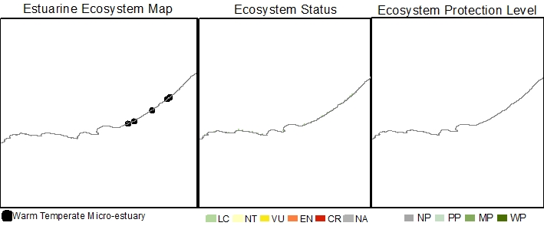
Estuarine Ecosystem type | Warm Temperate Micro-estuary
Ecosystem ID | To be provided by SANBI
NBA 2018 Coastal Classification | Coastal Classification NCM NBA2018 - To be provided by SANBI
Ecosystem type version history | 2018☐ 2024☐
Biogeographical Region | Warm Temperate
Ecosystem Threat Status (IUCN RLE v1.1): | Not Assessed
Assesment findings
Trigger criteria:
Other criteria considered:
Assessment Scope:

Assessment type:
Date assessed:
Year published:
Provincial distribution:
Historical extent (km²):
Remaining natural extent (%):
Conservation Target | 20 % (new ecosystem type, not included in 2011 National Estuaries Biodiversity Plan)
Area protected | ? %
Area under very high & high fishing pressure | ? %
Protection level from National Biodiversity Assessment 2018: | Not Assessed
Ecosystem description: | Micro-estuaries are defined as small, permanent coastal water bodies (>1ha in area or >50m in length) in which mixing of salt and freshwater can periodically occur owing to overwash from the sea or breaching of the mouth. These small systems are likely to support low densities of a limited number of estuarine and marine species.
Rain season: | Bimodal or Summer
Altitude: | Between 0 masl and 5 masl.
Mean Annual Precipitation:
Temperature:
Endemic taxa
Economically important taxa
Ecologically important taxa
Endemic taxa
Primary threatening processes:
Limitations and knowledge gaps | Very little data available for a systematic assessment
Estuaries in Ecosystem (estuary ID) | Dwesana (0)  Kaapsedrif ()  Klein Palmiet ()  Kwesani ()  Masiminana ()  Mbokotwana ()  Meul ()  Mvubukazi ()  Ngqenga ()  Salt ()  Shwele-Shwele ()  Thatshana ()  Warm Temperate 2 ()
Assessors | Van Niekerk, L., Adams, J.B., Lamberth, S.J., Turpie, J., MacKay, F., Sink, K. & Skowno, A.L
Reviewers | National Biodiversity Assessment Estuaries Reference Group (2016-2019) (2018 version).
Data sources | Dayaram, A., Skowno, A.L., Driver, A., Sink, K., Van Deventer, H., Smith-Adao, L., Van Niekerk, L., Harris, L.R., Job, N. & Nel, J.L. 2021. The South African National Ecosystem Classification System Handbook: First Edition. South African National Biodiversity Institute, Pretoria, South Africa. http://hdl.handle.net/20.500.12143/7150  GeoTerraImage (2015) Technical Report: 1990 South African National Land Cover Dataset version 5.2. Pretoria, 63 pp. SANBI Threatened Species Unit pers com (2020) Threatened plant species database of South Africa.  Van Niekerk, L, Adams JB, James, N, Lamberth S, Mackay F, Rajkaran A, Turpie J, Weerts S, Whitfield AK. 2020. An Estuary Ecosystem Classification that encompasses biogeography and a high diversity of types in support of protection and management. African Journal of Aquatic Science, 45: 199-216.  Van Niekerk, L., Adams, J.B., Lamberth, S.J., Turpie, J., MacKay, F., Sink, K. & Skowno, A.L., 2019, ‘Chapter 8: Ecosystem Threat Status and Protection levels’ in South African National Biodiversity Assessment 2018: Technical Report. Volume 3: Estuarine Realm. CSIR report number CSIR/SPLA/EM/EXP/2019/0062/A. South African National Biodiversity Institute, Pretoria. Report Number: http://hdl.handle.net/20.500.12143/6373.
Author (s) of Factsheet | Van Niekerk, L., Adams, J.B., Lamberth, Dayaram, A.
Recommended Citation | South African National Biodiversity Institute (2022-). [Name], Online, webpage link (unknown), accessed on [download date]
Image | [Link to images of ecosystem if available].*

24.3 Subtropical Micro-estuary
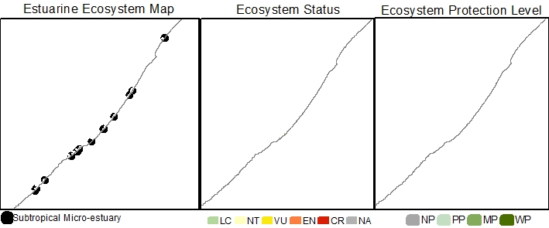
Estuarine Ecosystem type | Subtropical Micro-estuary
Ecosystem ID | To be provided by SANBI
NBA 2018 Coastal Classification | Coastal Classification NCM NBA2018 - To be provided by SANBI
Ecosystem type version history | 2018☒ 2024☐
Biogeographical Region | Subtropical
Ecosystem Threat Status (IUCN RLE v1.1): | Not Assessed
Assesment findings
Trigger criteria:
Other criteria considered:
Assessment Scope:

Assessment type:
Date assessed:
Year published:
Provincial distribution: | Eastern Cape and KwaZulu-Natal
Historical extent (km²):
Remaining natural extent (%):
Conservation Target | 20 % (new ecosystem type, not included in 2011 National Estuaries Biodiversity Plan)
Area protected | ? %
Natural Area under very high & high fishing pressure | ? %
Protection level from National Biodiversity Assessment 2018: | Not Assessed
Ecosystem description: | Micro-estuaries are defined as small, permanent coastal water bodies (>1ha in area or >50m in length) in which mixing of salt and freshwater can periodically occur owing to overwash from the sea or breaching of the mouth. These small systems are likely to support low densities of a limited number of estuarine and marine species.
Rain season: | Summer
Altitude: | Between 0 masl and 5 masl.
Mean Annual Precipitation:
Temperature:
Endemic taxa
Economically important taxa
Ecologically important taxa
Endemic taxa
Primary threatening processes:
Limitations and knowledge gaps | Very little data available for a systematic assessment
Estuaries in Ecosystem (estuary ID) | Dakana (0)  Dakane ()  Gugu ()  Kilroe Beach ()  Ku-Bomvu ()  Magogo ()  Maviti ()  Mguga ()  Mtonjane ()  Ntupeni ()  Ntyivini ()  Nyumbazana ()  Subtropical 21 ()  Subtropical 22 ()  Subtropical 33 ()  Subtropical 44 ()  Subtropical 46 ()  Subtropical 66 ()  Subtropical 69 ()  Subtropical 70 ()  Subtropical 73 ()  Subtropical 81 ()  Subtropical 85 ()  Tezana ()
Assessors | Van Niekerk, L., Adams, J.B., Lamberth, S.J., Turpie, J., MacKay, F., Sink, K. & Skowno, A.L
Reviewers | National Biodiversity Assessment Estuaries Reference Group (2016-2019) (2018 version).
Data sources | Dayaram, A., Skowno, A.L., Driver, A., Sink, K., Van Deventer, H., Smith-Adao, L., Van Niekerk, L., Harris, L.R., Job, N. & Nel, J.L. 2021. The South African National Ecosystem Classification System Handbook: First Edition. South African National Biodiversity Institute, Pretoria, South Africa. http://hdl.handle.net/20.500.12143/7150  GeoTerraImage (2015) Technical Report: 1990 South African National Land Cover Dataset version 5.2. Pretoria, 63 pp. SANBI Threatened Species Unit pers com (2020) Threatened plant species database of South Africa.  Van Niekerk, L, Adams JB, James, N, Lamberth S, Mackay F, Rajkaran A, Turpie J, Weerts S, Whitfield AK. 2020. An Estuary Ecosystem Classification that encompasses biogeography and a high diversity of types in support of protection and management. African Journal of Aquatic Science, 45: 199-216.  Van Niekerk, L., Adams, J.B., Lamberth, S.J., Turpie, J., MacKay, F., Sink, K. & Skowno, A.L., 2019, ‘Chapter 8: Ecosystem Threat Status and Protection levels’ in South African National Biodiversity Assessment 2018: Technical Report. Volume 3: Estuarine Realm. CSIR report number CSIR/SPLA/EM/EXP/2019/0062/A. South African National Biodiversity Institute, Pretoria. Report Number: http://hdl.handle.net/20.500.12143/6373.
Author (s) of Factsheet | Van Niekerk, L., Adams, J.B., Lamberth, Dayaram, A.
Recommended Citation | South African National Biodiversity Institute (2022-). [Name], Online, webpage link (unknown), accessed on [download date]
Image | [Link to images of ecosystem if available].*

References

Skowno, A.L., Poole, C.J., Raimondo, D.C., Sink, K.J., Van Deventer, H., Van Niekerk, L., Harris, L.R., Smith-Adao, L.B., Tolley, K.A., Zengeya, T.A., Foden, W.B., Midgley, G.F. & Driver, A. 2019. National Biodiversity Assessment 2018: The status of South Africa’s ecosystems and biodiversity. Synthesis Report. South African National Biodiversity Institute, an entity of the Department of Environment, Forestry and Fisheries, Pretoria.

Van Niekerk, L, Adams JB, James, N, Lamberth S, Mackay F, Rajkaran A, Turpie J, Weerts S, Whitfield AK. 2020. An Estuary Ecosystem Classification that encompasses biogeography and a high diversity of types in support of protection and management. African Journal of Aquatic Science, 45: 199-216.

Van Niekerk L, Adams JB Lamberth SJ, MacKay F, Taljaard S, Turpie JK, Weerts S, Raimondo DC (eds). 2019b. South African National Biodiversity Assessment 2018: Technical Report. Volume 3: Estuarine Realm. CSIR report number CSIR/SPLA/EM/EXP/2019/0062/A. South African National Biodiversity Institute, Pretoria. Report Number: SANBI/NAT/NBA2018/2019/Vol3/A.

